

**VA Form 10182  
Board Appeal  
(Notice of Disagreement)**

Version 2.0  
October 2024

Version History

| Date | Version | Description | Author |
| --- | --- | --- | --- |
| 2/26/2024 | 1 | Version 2 release | Ruben Sun |
| October 2024 | 2 | Update with error notification | Maurice DeBeary |

# Table of Contents

**Overview**

What is it?

**Navigating and Accessing the Notice of Disagreement Form**

Sign-in

Navigating directly

Navigating through VA.gov

Alternate Methods to Locate the Board Appeal Form

Via search

Via decision letter

Via claim detail page

Starting the Board Appeal Request

Step 1: Veteran Information

Confirm the contact information on file

Confirm housing status

Review contact information

Step 2: Issues for Review

Review deadlines for appeal eligibility

Appeal characteristics (request extension, appeal VA health care benefit denial)

Request an extension

Request an appeal against a denial of VA health care benefits

Select issues for review

Adding an issue not listed

Providing reasons for disagreement for each selected issue

Reviewing issues for appeal

Step 3: Select a Board Review Option

Submitting additional evidence (for Veterans opting to submit more evidence)

Selecting a hearing option (for Veterans opting to request a hearing)

Step 4: Review and Submit Appeal Request

Viewing responses

Editing responses

Submitting the appeal request

Appeal request submission confirmation

Saving Progress and Returning to the Submission Request

Saving progress

Resuming progress

Starting over

# Overview

This product guide is designed to provide comprehensive support to Veterans through the online form for filing a notice of disagreement / requesting a board appeal (VA Form 10182).

## What is it?

The notice of Disagreement is an online form designed to request an appeal of a benefit decision with a Veterans Law Judge at the Board of Veterans’ Appeals. It corresponds with VA Form 10182 and provides an alternative to filing in person with a VA regional office, by mail, or by fax.

The form empowers Veterans to select the issues they wish to appeal, provide reasons for disagreeing with VA’s decision, choose a review or hearing option, and submit their information for VA to review. Optionally, Veterans may also submit additional evidence as a part of their appeal request.

This guide outlines the steps involved in the process.

# Navigating and Accessing the Notice of Disagreement Form

### Sign-in

Veterans must be signed in to enter and submit this online form. Sign-in can be performed either before or after navigating to the form page.

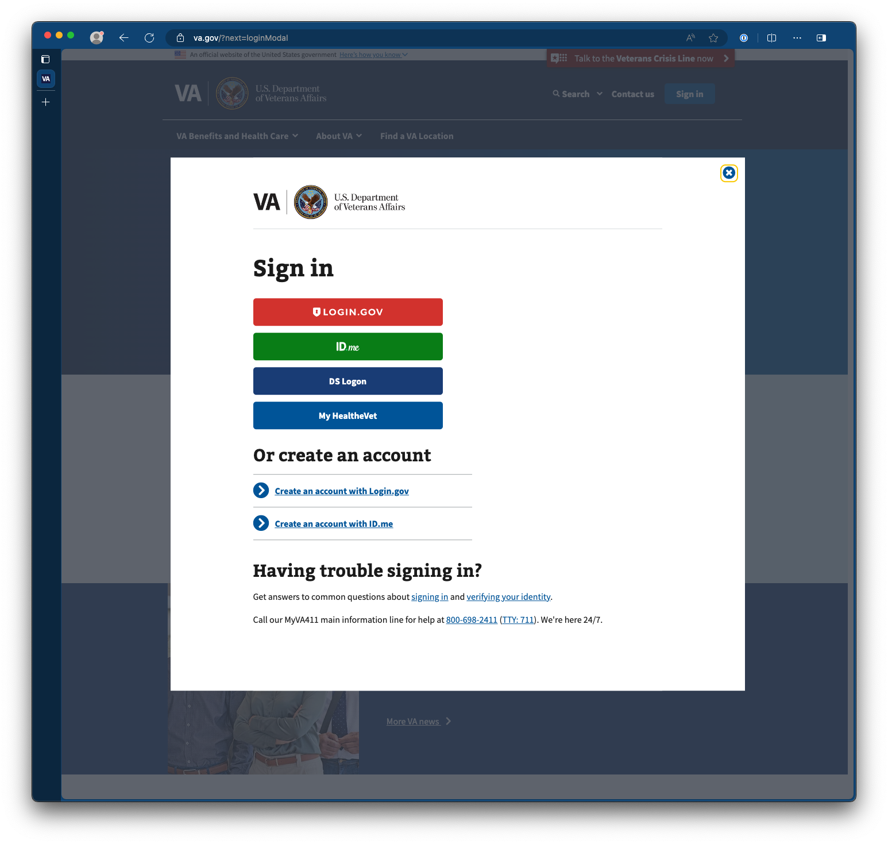

If they have not yet signed in before arriving at the form page, they will be directed to do so upon arrival.

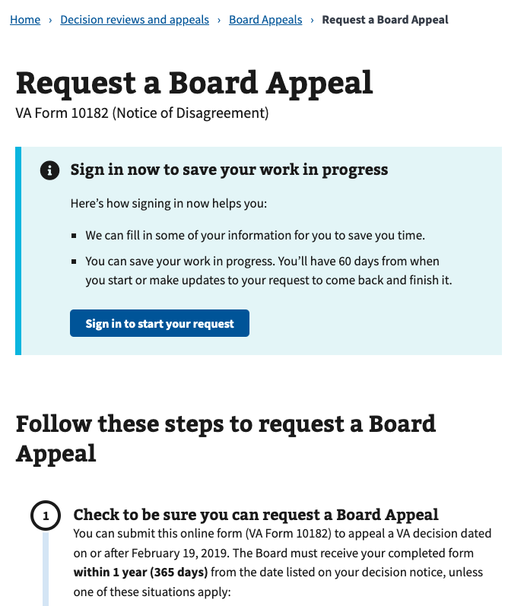

### Navigating directly

Veterans can reach the form page by directing their web browser to the URL:  
<http://va.gov/decision-reviews/board-appeal/request-board-appeal-form-10182>.

### Navigating through VA.gov

The online Notice of Disagreement form can be located in the disability section of VA.gov. To navigate to the form, navigate to request a decision review or appeal.

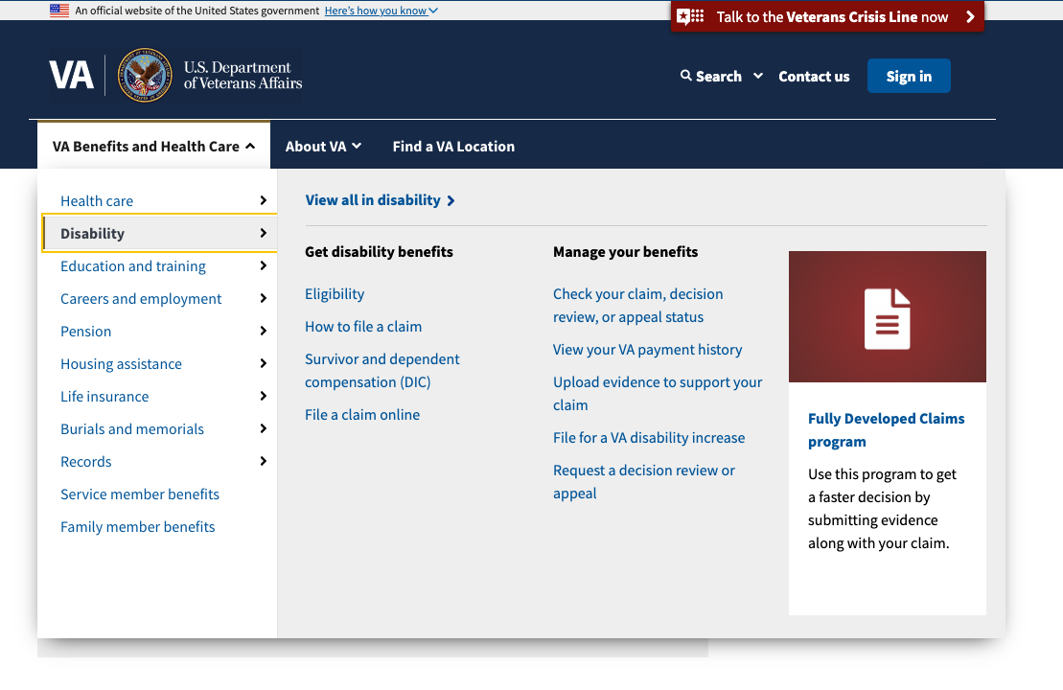

In VA Decision Reviews and Appeals, navigate to the Decision Review option: Board Appeal, listed under the options to Request a Decision Review.

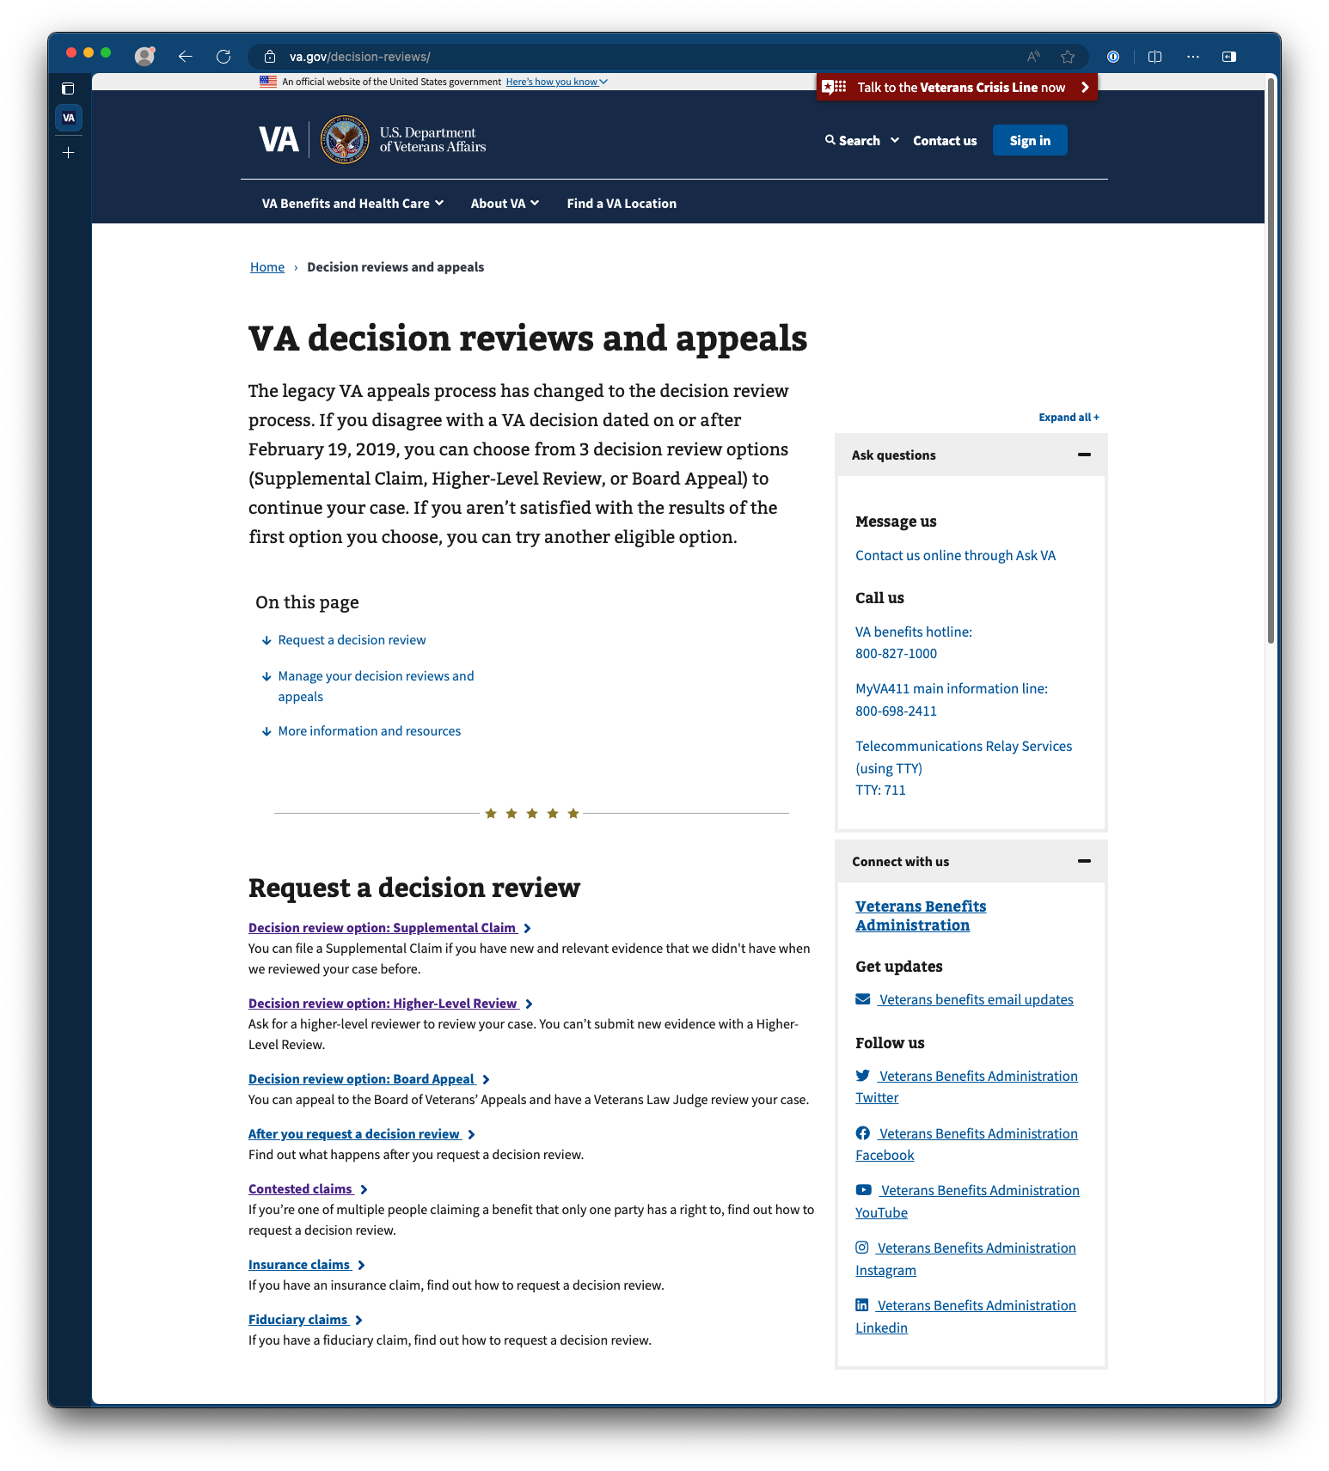

## Alternate Methods to Locate the Board Appeal Form

### Via search

The board appeal form can also be accessed via the global search in the VA.gov main navigation or form finder (Find a VA form) through the keywords “Board appeal” or “Notice of Disagreement.”

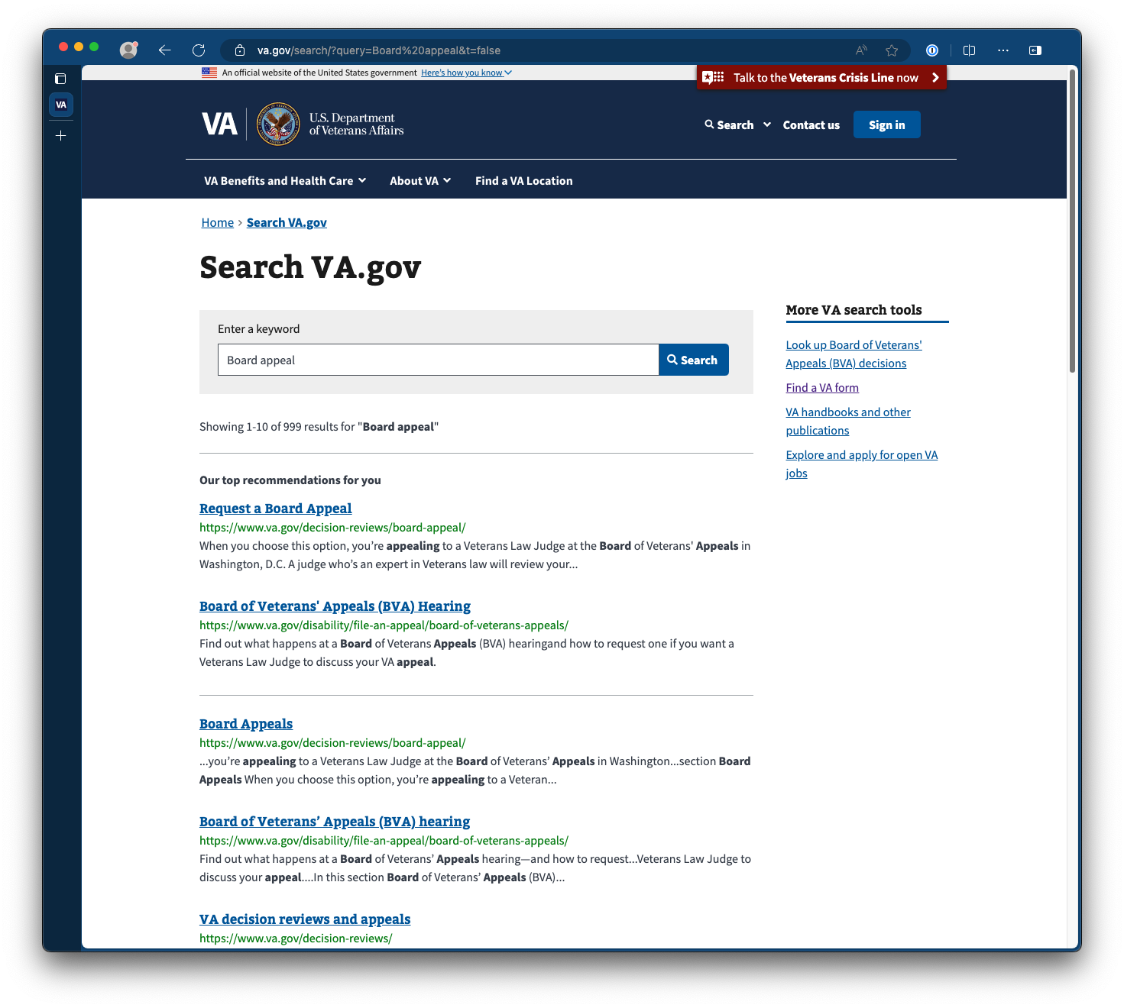

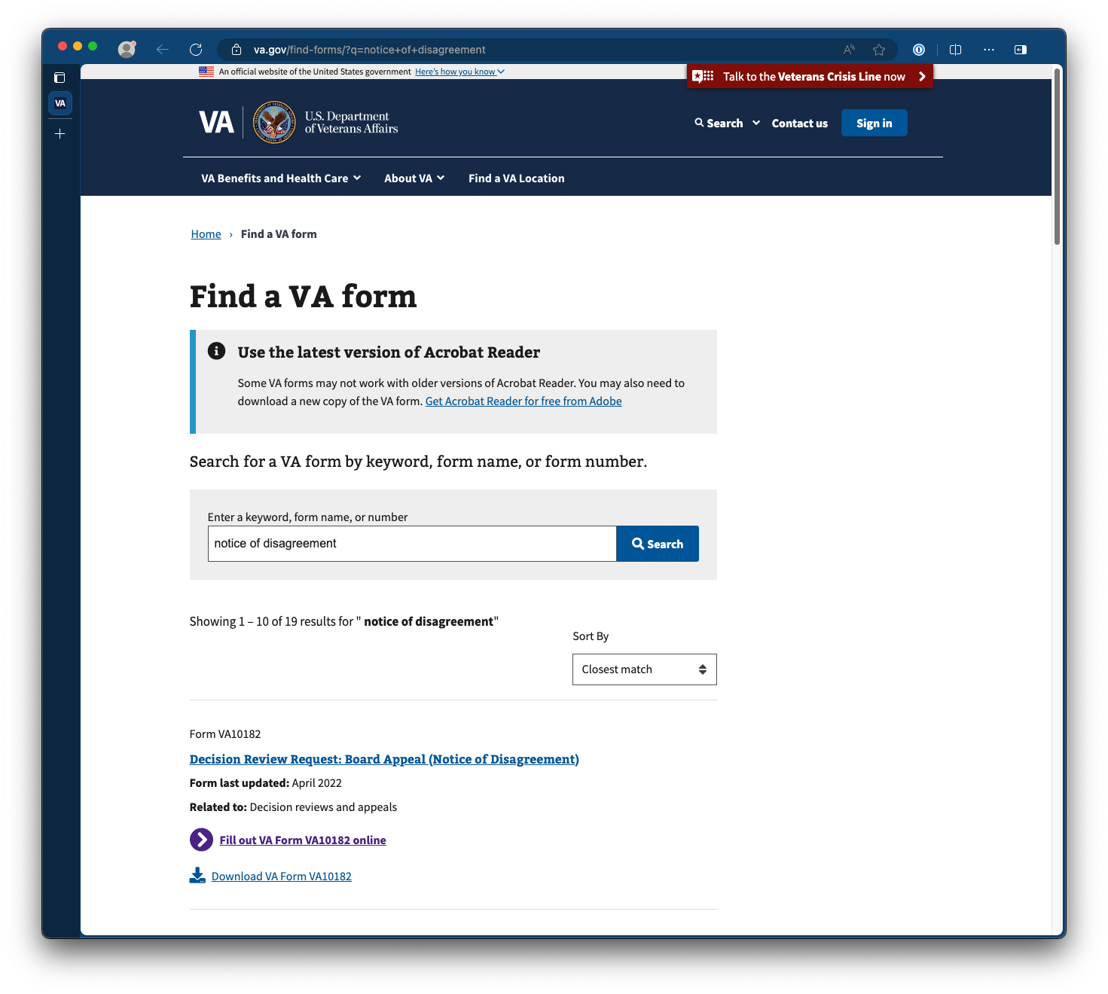

### Via decision letter

Veterans are also directed to the decision review options page from a decision letter under the section What You Should Do If You Disagree With Our Decision, where they can locate the option for requesting a Board Appeal.

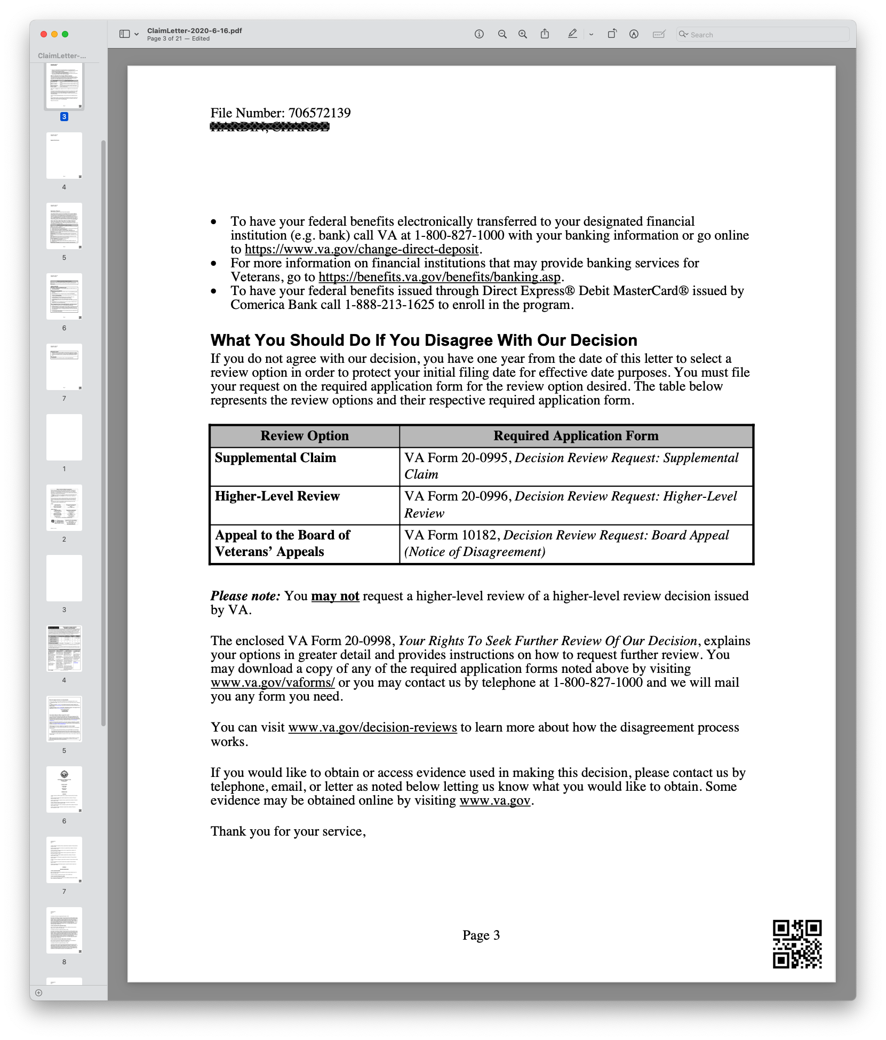

### Via claim detail page

A link to decision review options can also be found on the claim detail page under the options listed under Next Steps.

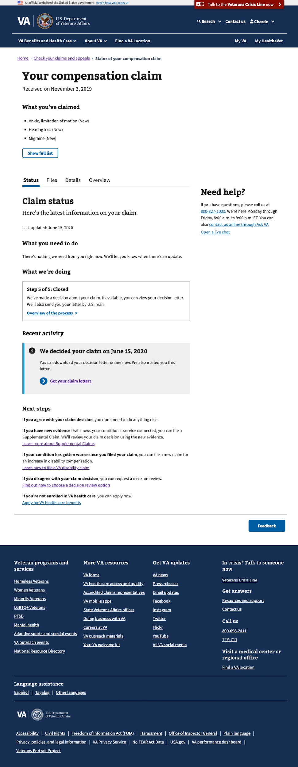

Form Entry, Review, and Submission

The Notice of Disagreement form is organized into 4 steps:

1. **Veteran information**  
   Confirm the contact information on file and the claimant's housing status.
2. **Issues for review**  
   Review deadlines for appeal eligibility and supply details surrounding the issues and reasons for requesting a board appeal.
3. **Board review option**  
   Select from 3 board review options and provide details surrounding the type of hearing requested.
4. **Review your request and submit**   
   The 'review and submit' step is the final stage of the process. Here, the Veteran can review the details of their appeal request before submitting it for VA to process.

## Starting the board appeal request

On the Board Appeal page, the action to start the board appeal form can be found halfway down the page under the heading How do I request a Board Appeal through a link labeled Request a Board Appeal.

This action can also be in the side navigation with a link sharing the same label, Request a Board Appeal.

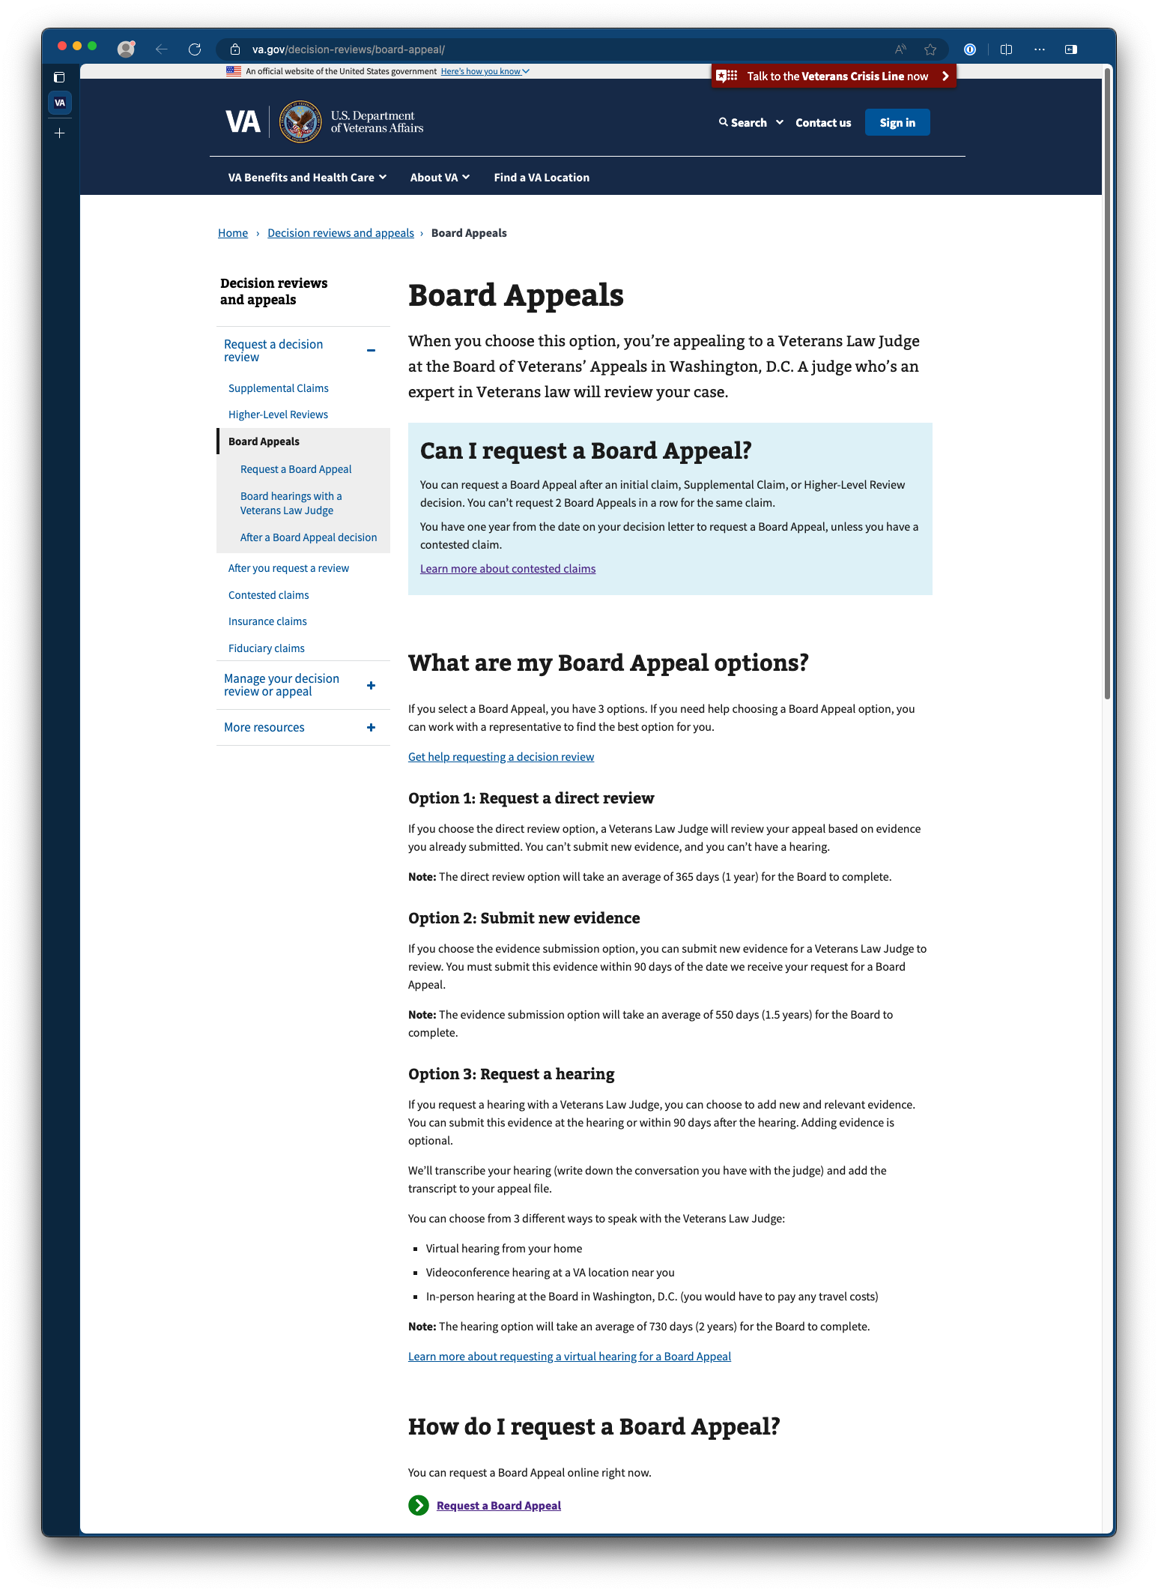

Next, they will be presented with instructions for filing their appeal. To start their board appeal, press the call to action labeled Start the Board appeal request.

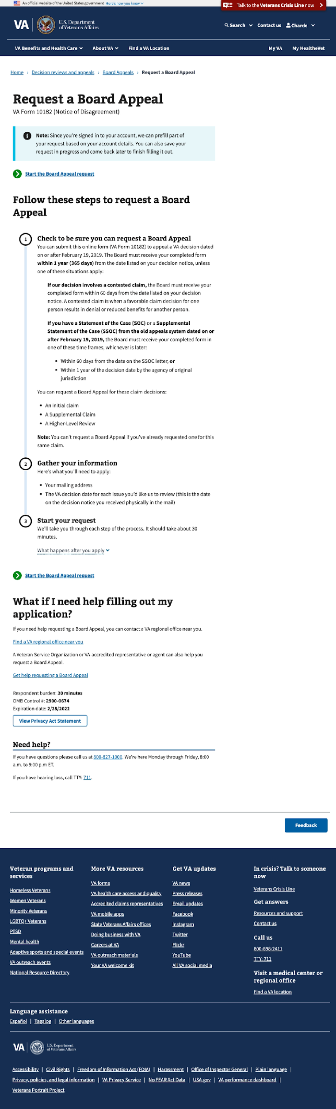

## Step 1: Veteran Information

#### Confirm the contact information

As the Veteran begins the board appeal form, they will be asked to confirm the personal information VA has on file.

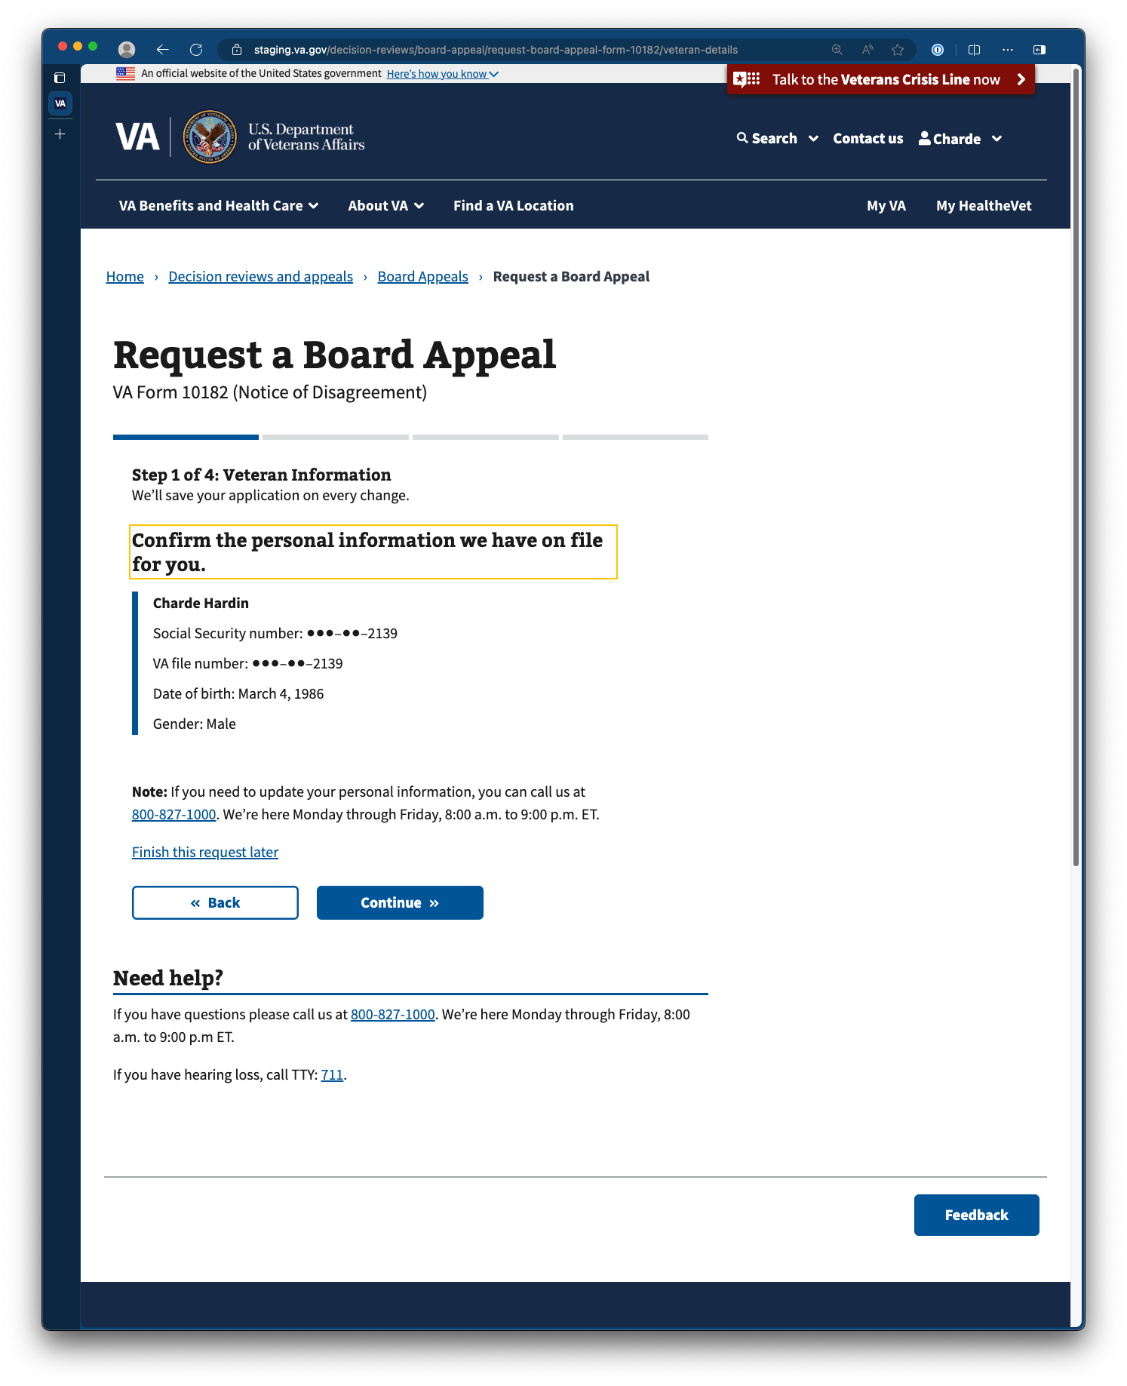

#### Confirm housing status

Upon clicking continue, the Veteran will be prompted to provide their housing status. Housing status is collected to inform us of the priority of the request.

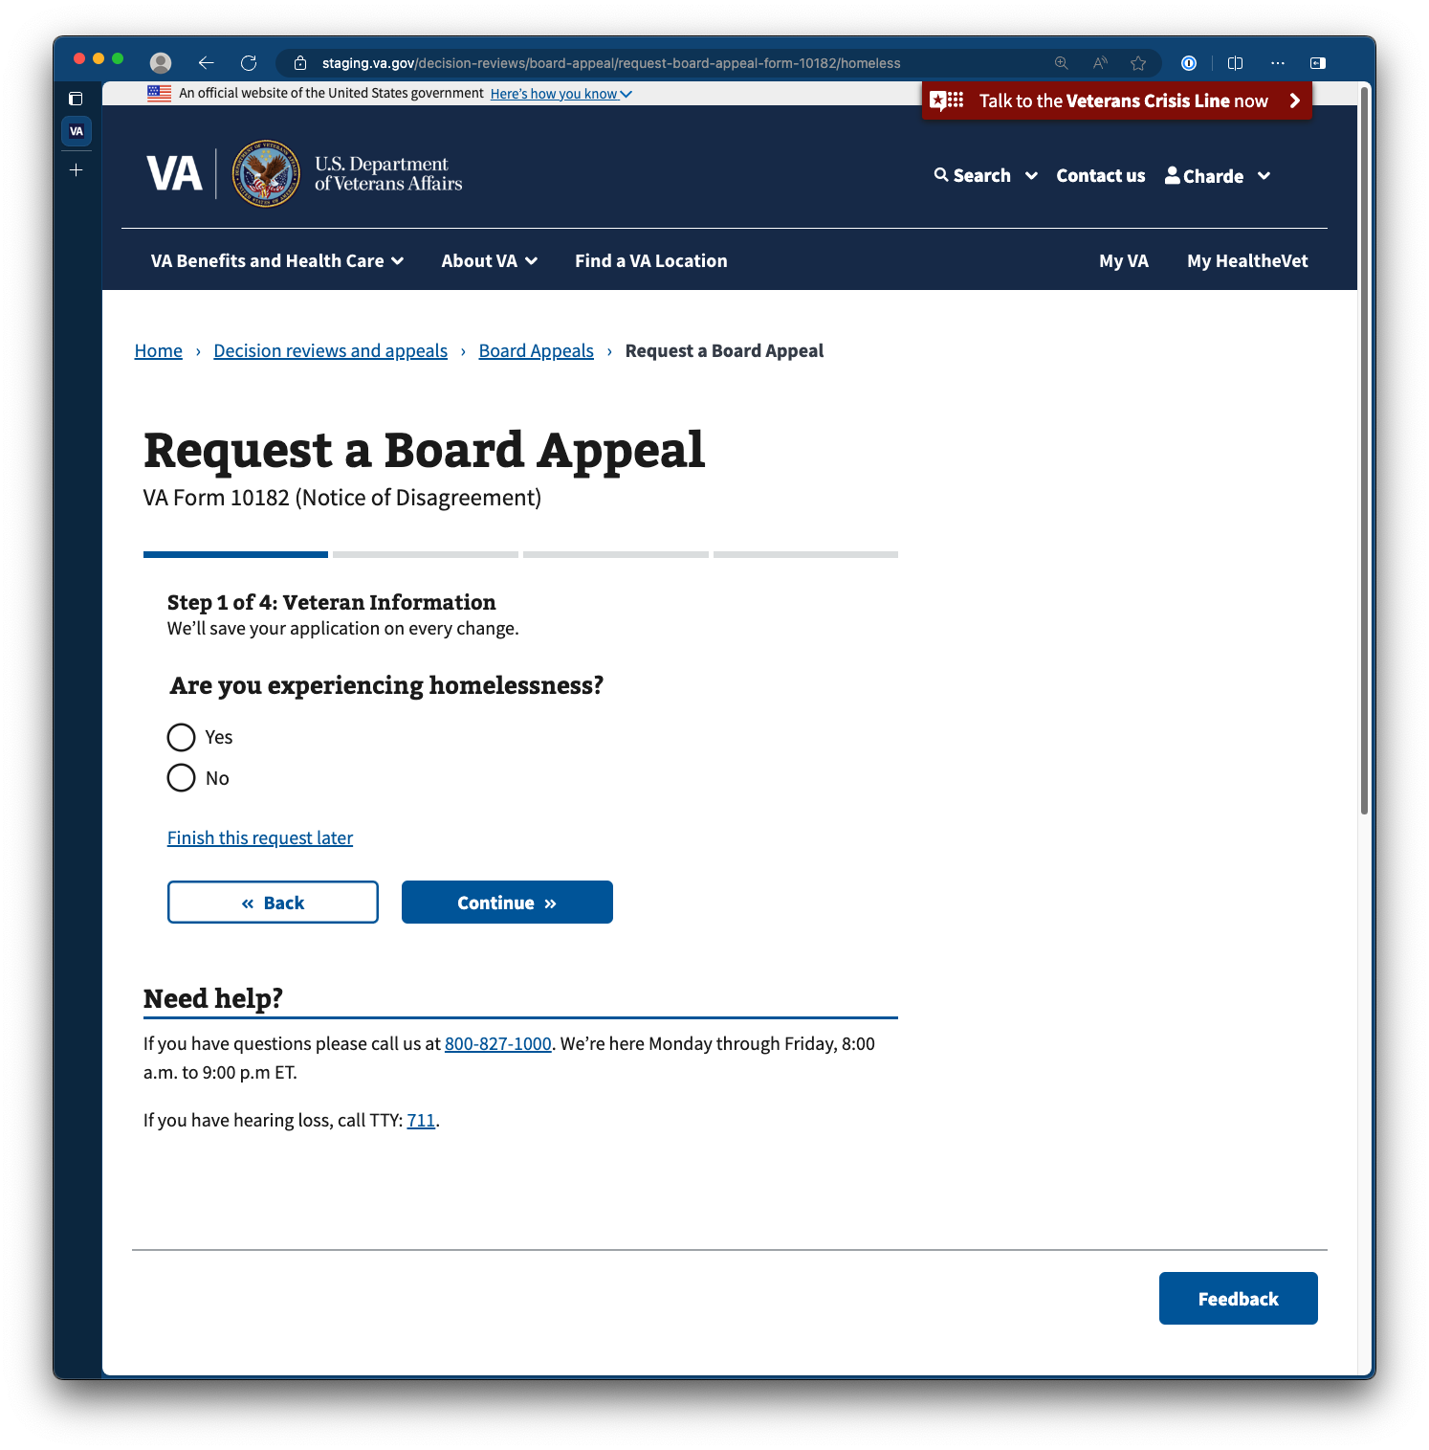

#### Review contact information

Upon clicking continue, the Veteran will be prompted to review their contact information. If Veterans need to update or change this information, they can do so by clicking edit. Any changes made to the contact information in this form will also update the contact information in the Veteran’s profile on VA.gov.

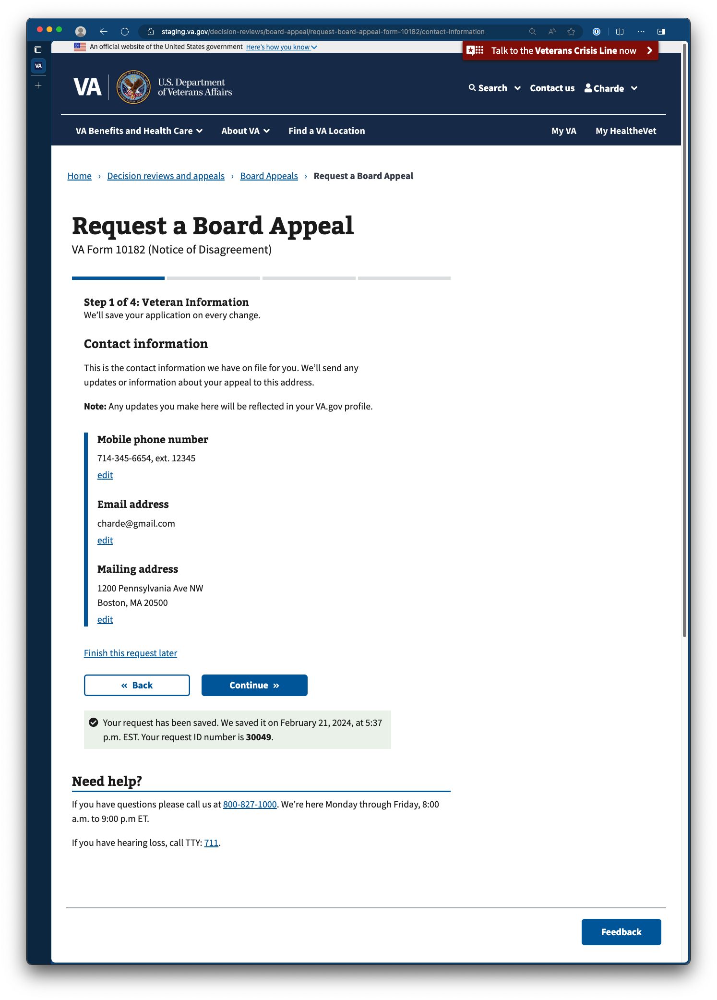

. 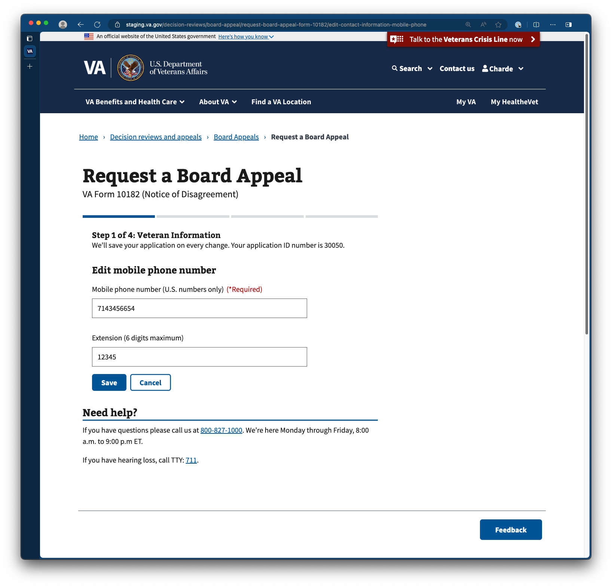

## Step 2: Issues For Review

### Review deadlines for appeal eligibility

After confirming contact information on file and providing housing status, Veterans are provided information surrounding their deadlines for appeal eligibility. Should the Veteran file an appeal regarding an issue currently pending in the legacy appeal process, the new appeal will opt the issue into the new decision review process and remove the issue from the legacy appeal queue.  
   
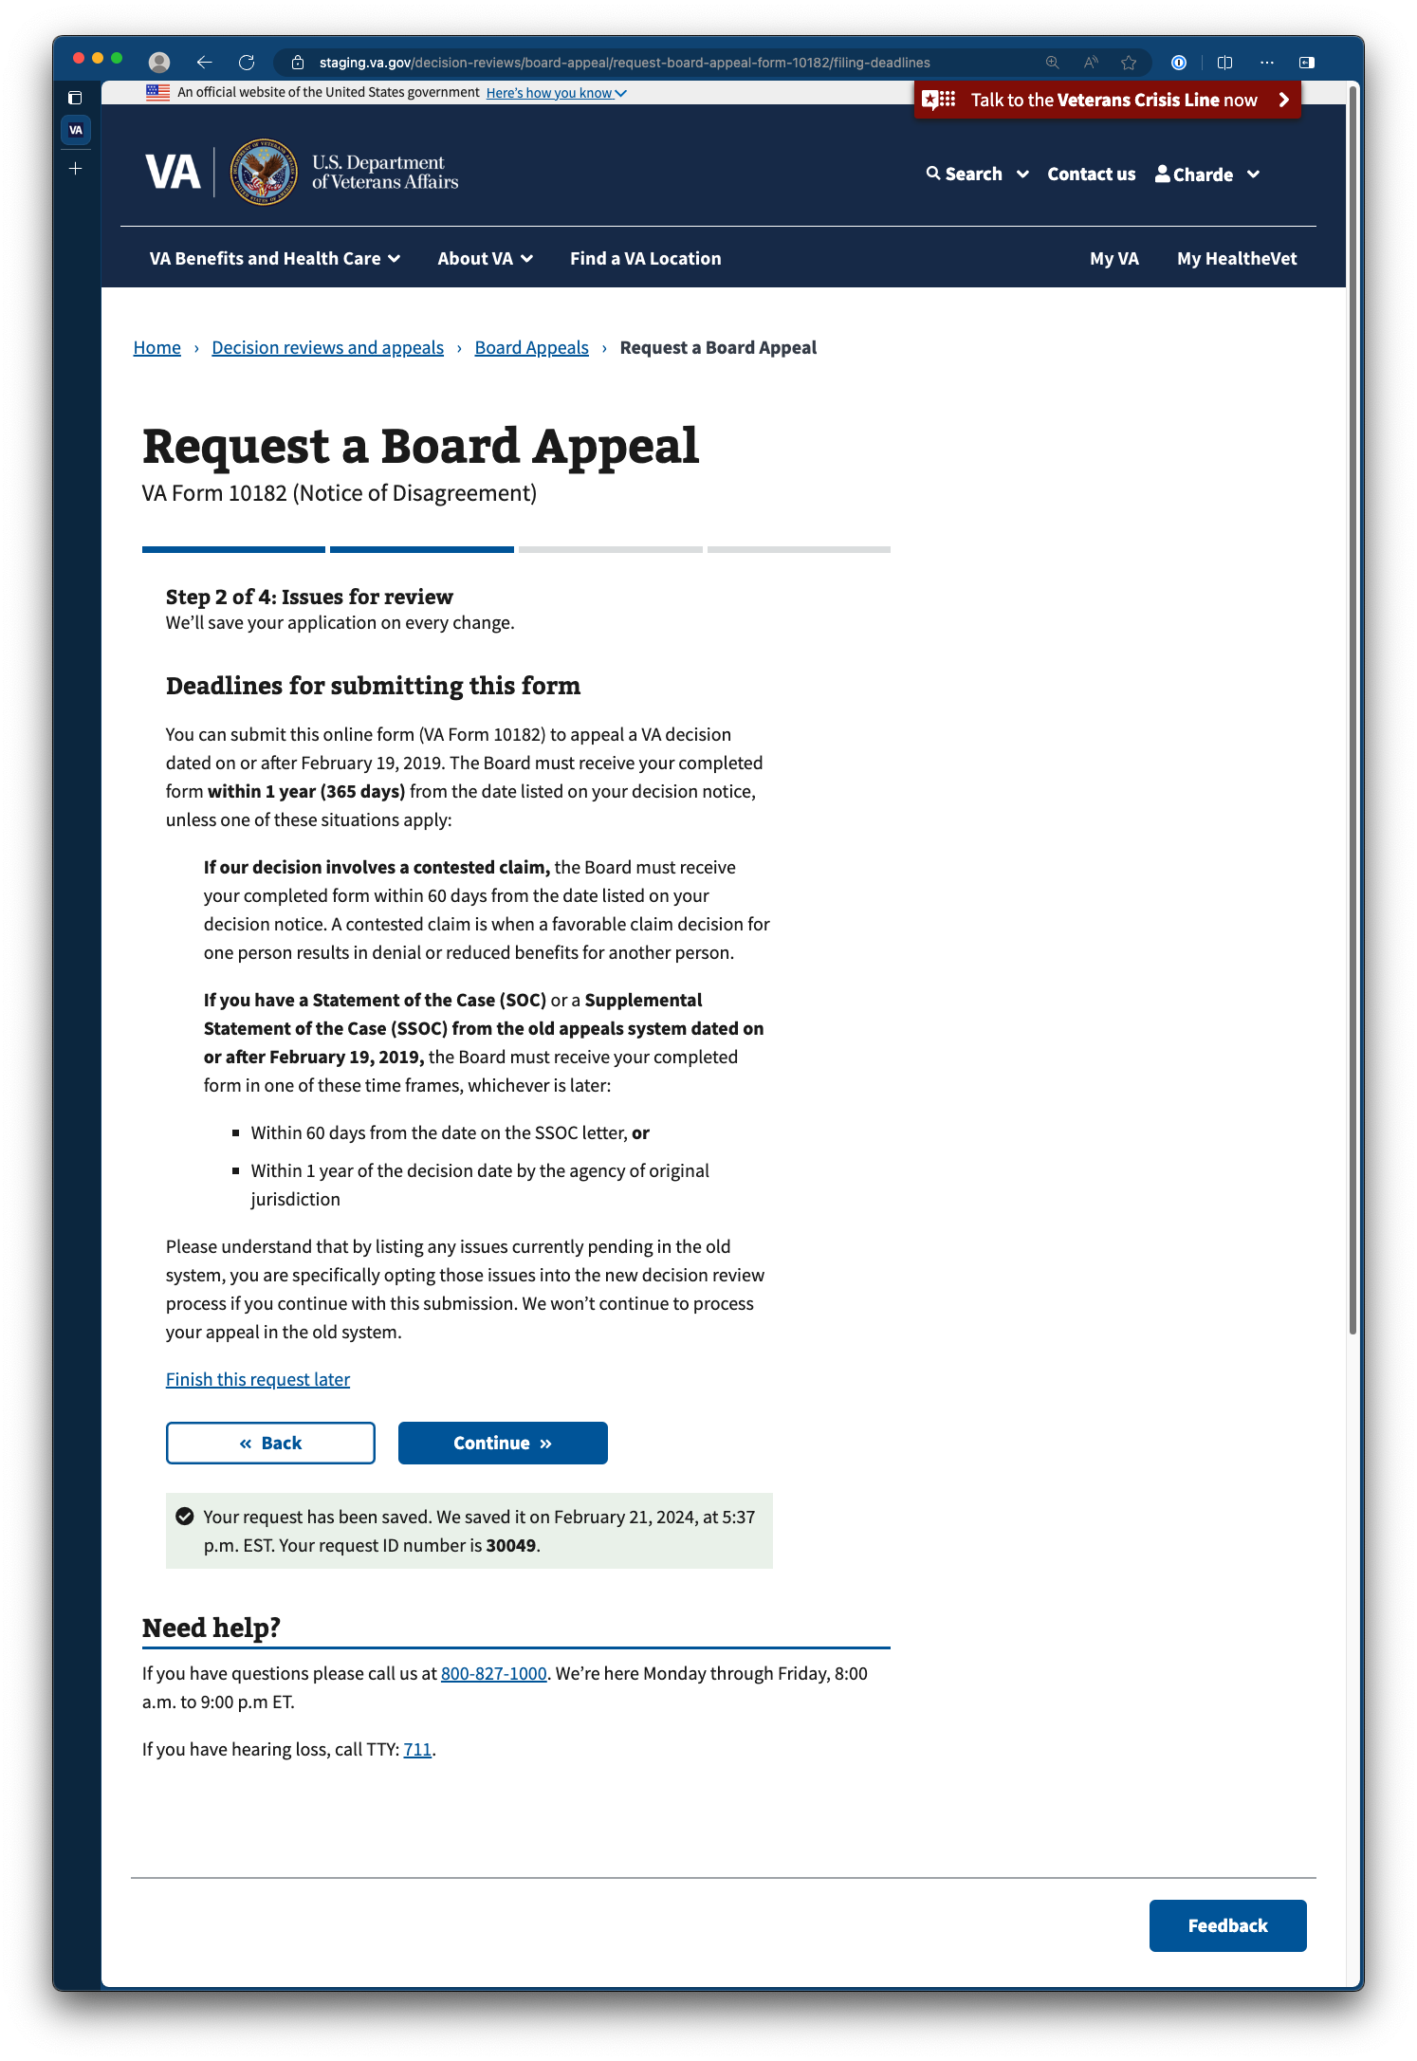

### Appeal characteristics (request extension, appeal VA health care benefit denial)

Following receipt of appeal deadlines, Veterans are prompted with additional qualifying questions regarding the nature of the appeal, whether the appeal is an extension request or an appeal regarding VA health care benefit denial. It is okay for Veterans to answer no to both questions.

#### Request an extension

Veterans are prompted to identify whether the appeal is an extension request for a claim or an appeal reaching its eligibility deadline. If Veterans select yes, they are given an area to provide their reason for requesting an extension.

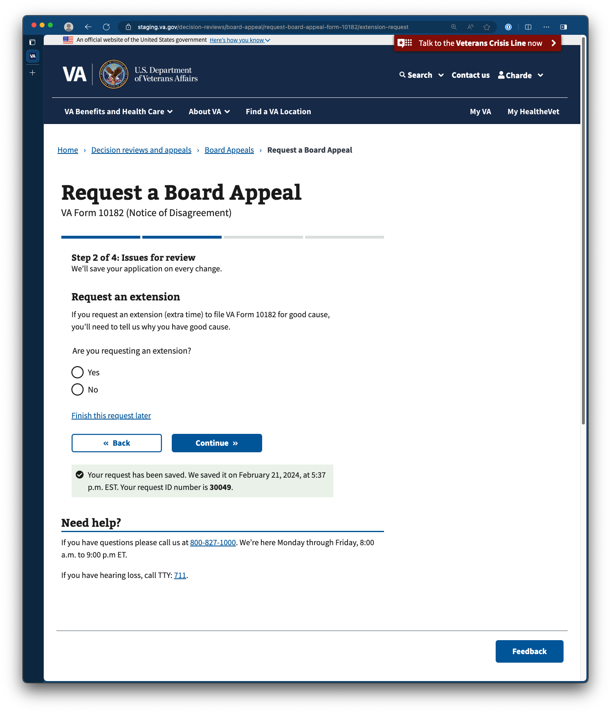

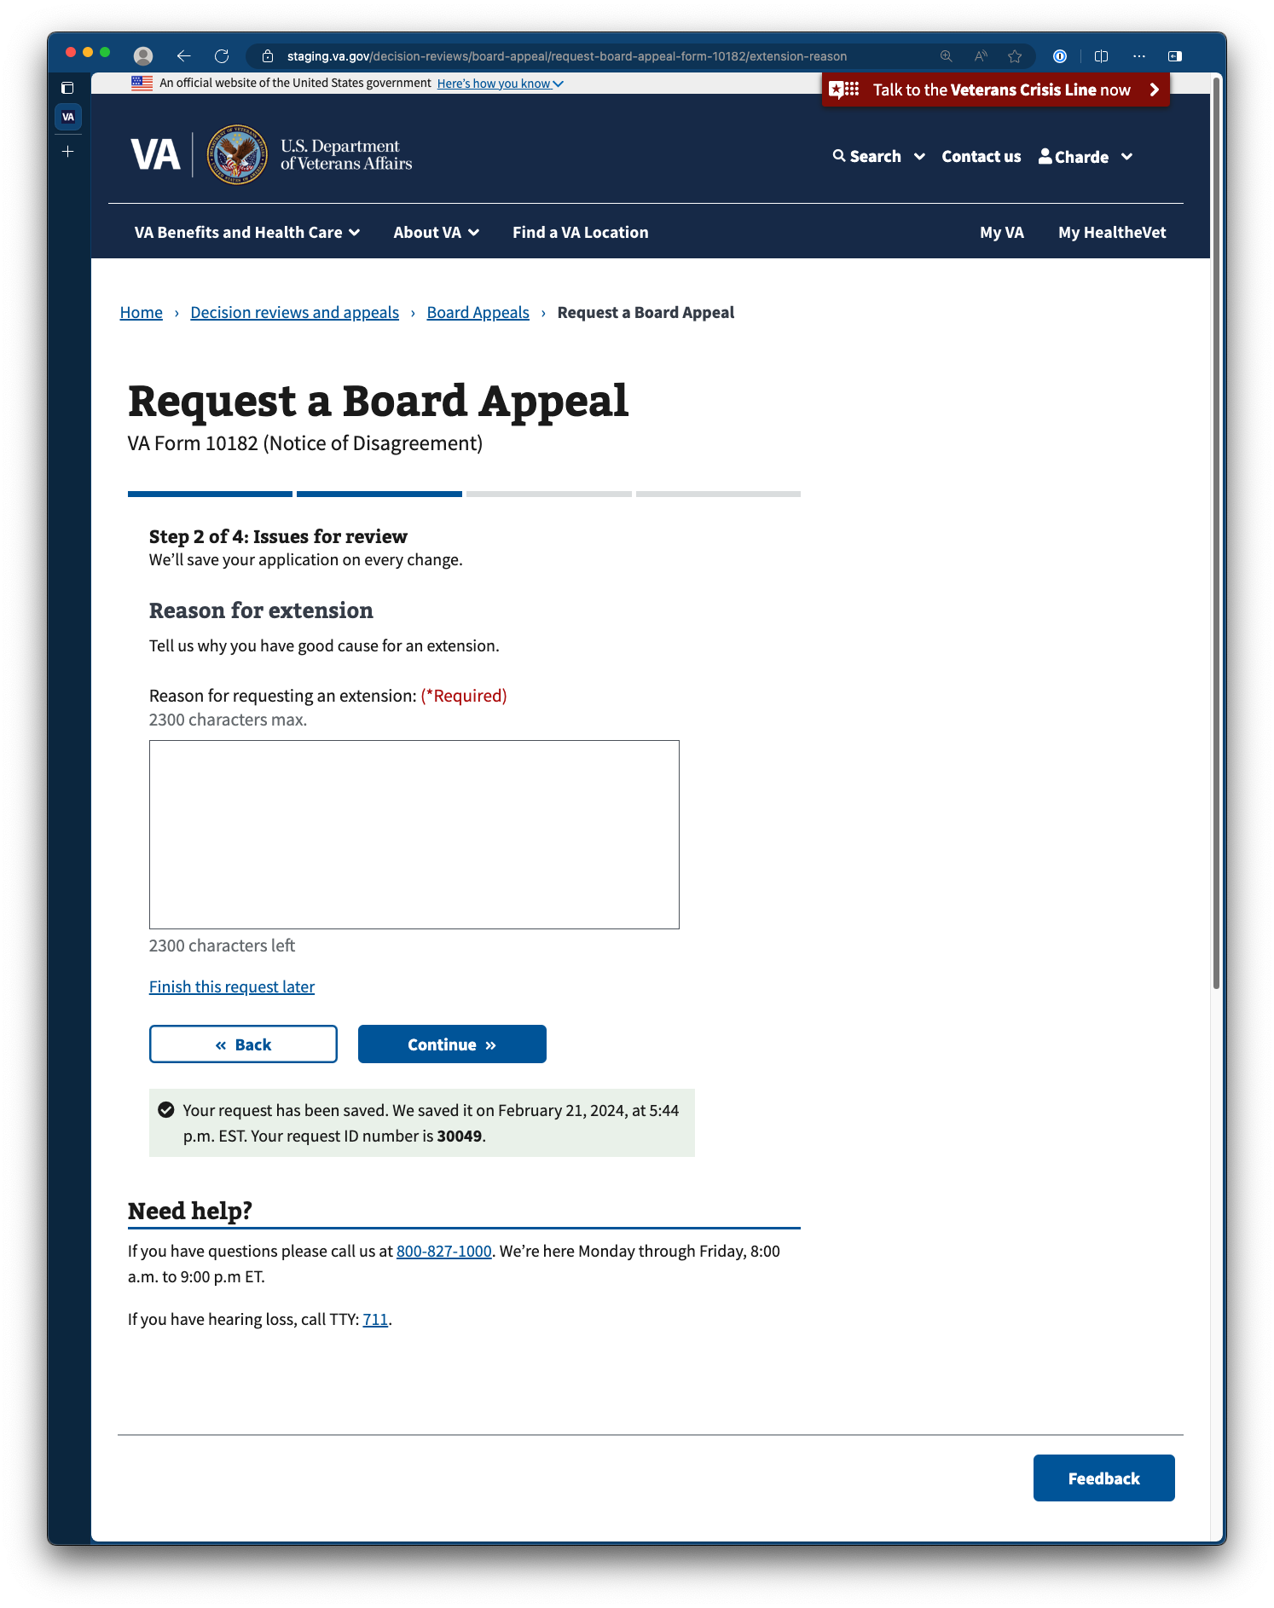

#### Request an appeal against a denial of VA health care benefits

Veterans are prompted to identify whether the appeal relates to a denial of VA health benefits. By requesting an appeal against a denial of VA health care benefits, the Veteran’s appeal will be processed through the Veterans Health Administration (VHA) and the Board of Veterans’ Appeals (BVA).

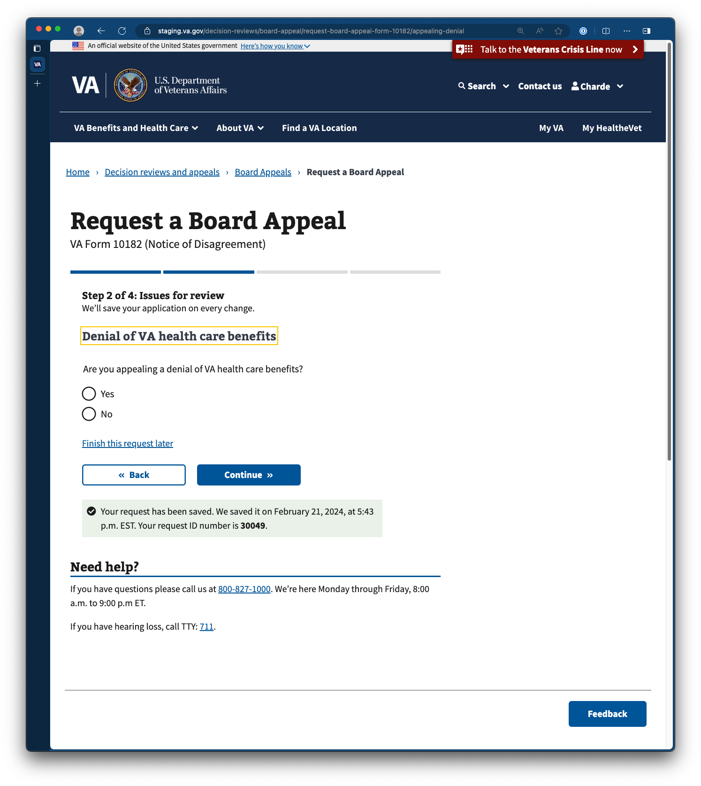

### Select issues for review

Following the qualifying questions regarding the appeal, Veterans are asked to select or enter the specific issues they want VA to review. They’re provided with a list of claimed issues from which to choose.

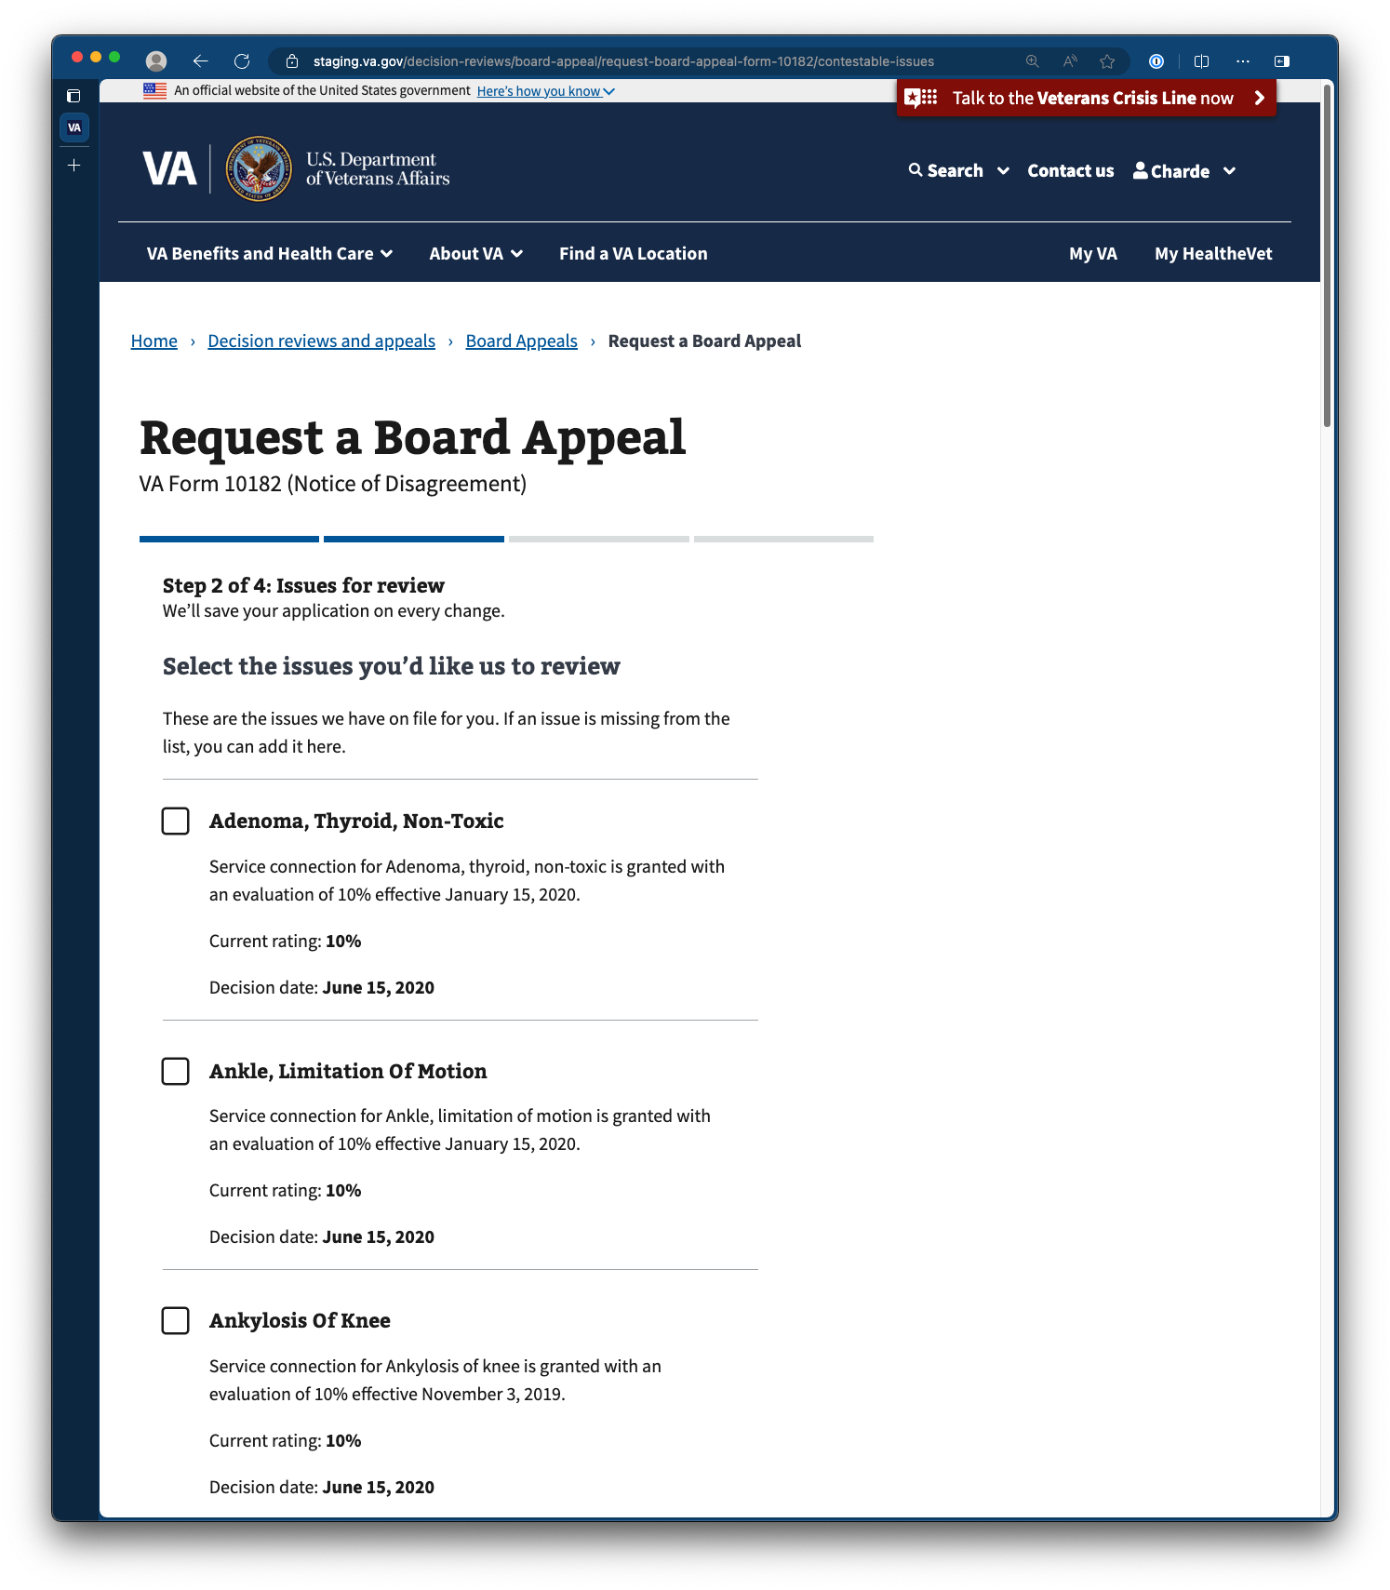

#### Adding an issue not listed

If the issue the Veteran wishes to have reviewed doesn’t appear in the list, they can manually add additional issues through the action labeled Add a new issue located at the bottom of the list.

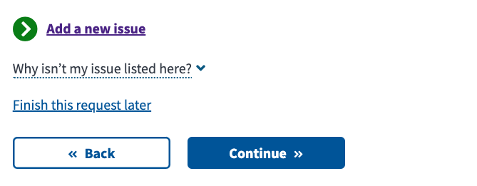  


The action to add a new issue is intended for issues for which Veterans have already claimed and received a decision. As Veterans manually add new issues, they will be asked to provide the name and decision date for the issue (effective date).  
  
The effective date may be in the notification letter where they received their decision. Veterans seeking to claim an additional disability or secondary service-connected condition are better served by filing an additional 526 claim. Newly claimed issues may take up to 120 extra days to be decided.

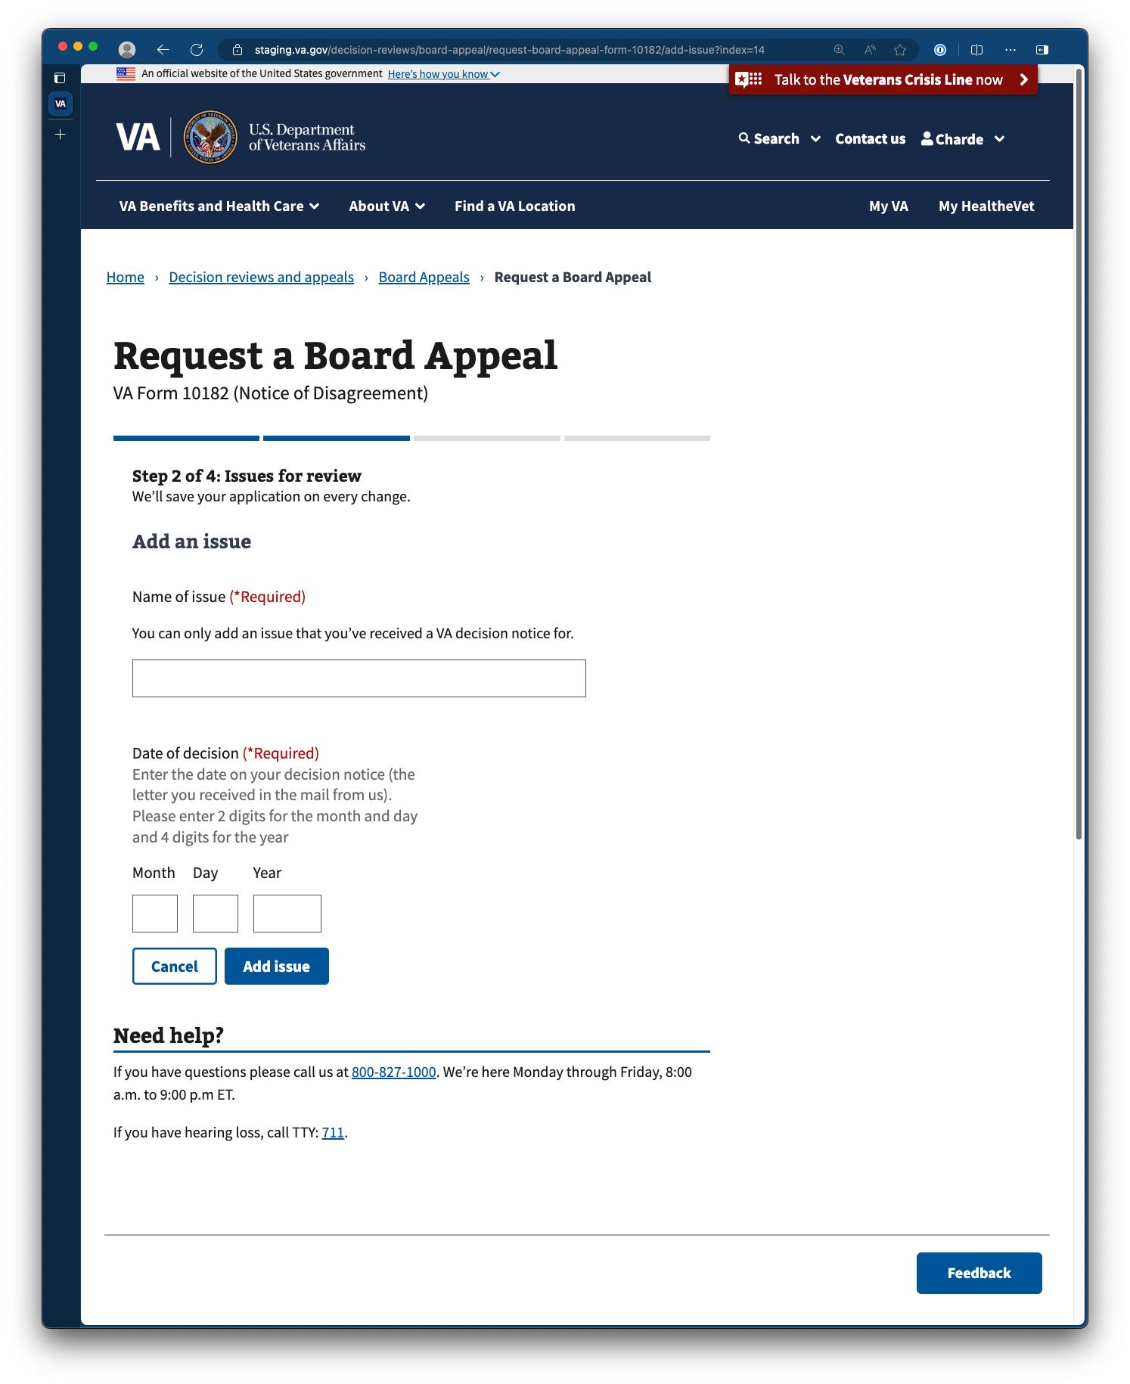

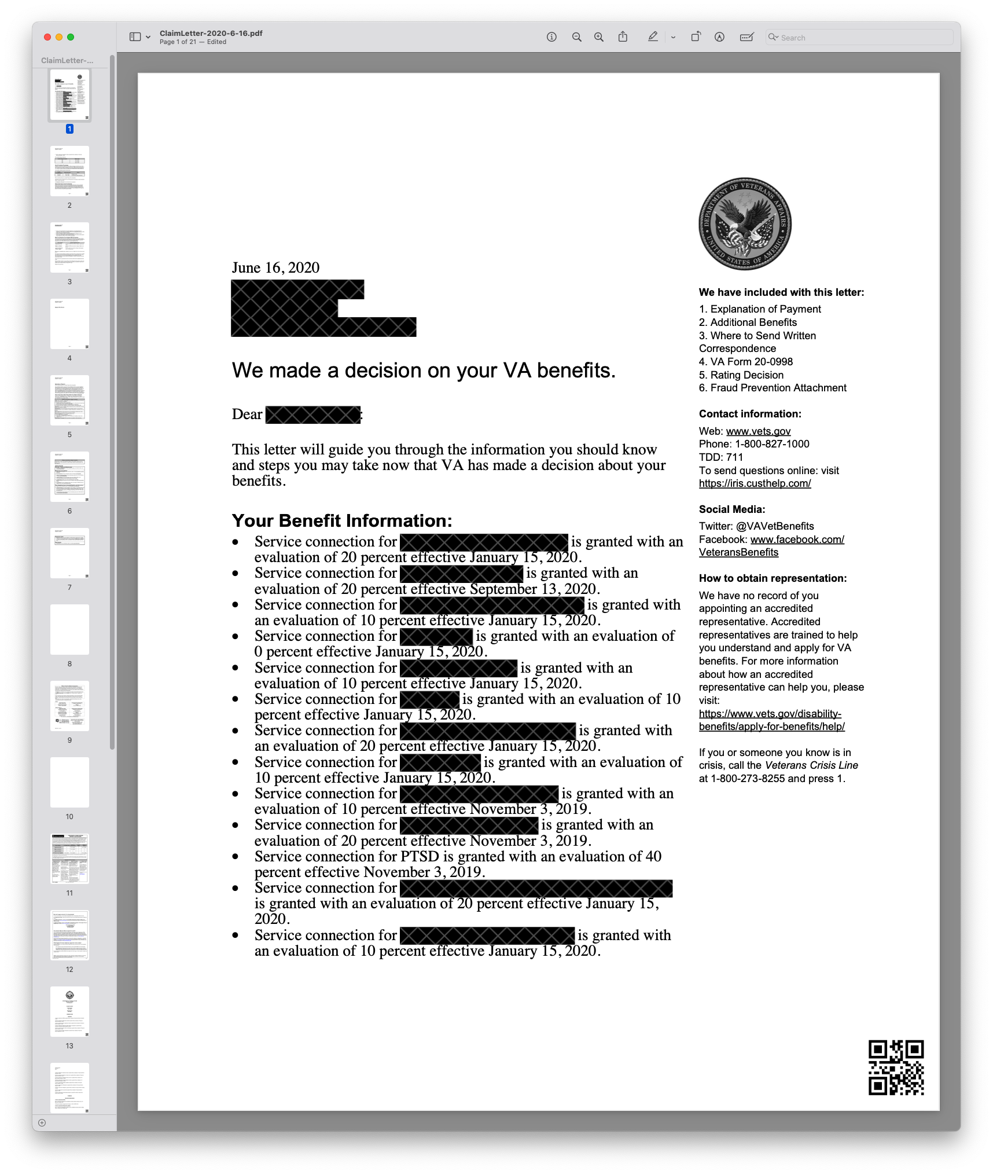

### Providing reasons for disagreement for each selected issue

Following the selection or entry of issues for review, Veterans are asked to provide their reason for disagreement with each issue. Veterans can select from 3 options (the service connection, effective date of award, or evaluation of the condition) or provide a different reason.

This field is intended to support claims processors in identifying the nature of the disagreement and is not meant for Veterans to supply additional context or information about their appeal. To provide further context, Veterans are advised to attach a Statement in Support of Claim to the appeal ([VA Form 21-4138](https://www.va.gov/find-forms/about-form-21-4138/)). This form can be found elsewhere on VA.gov.

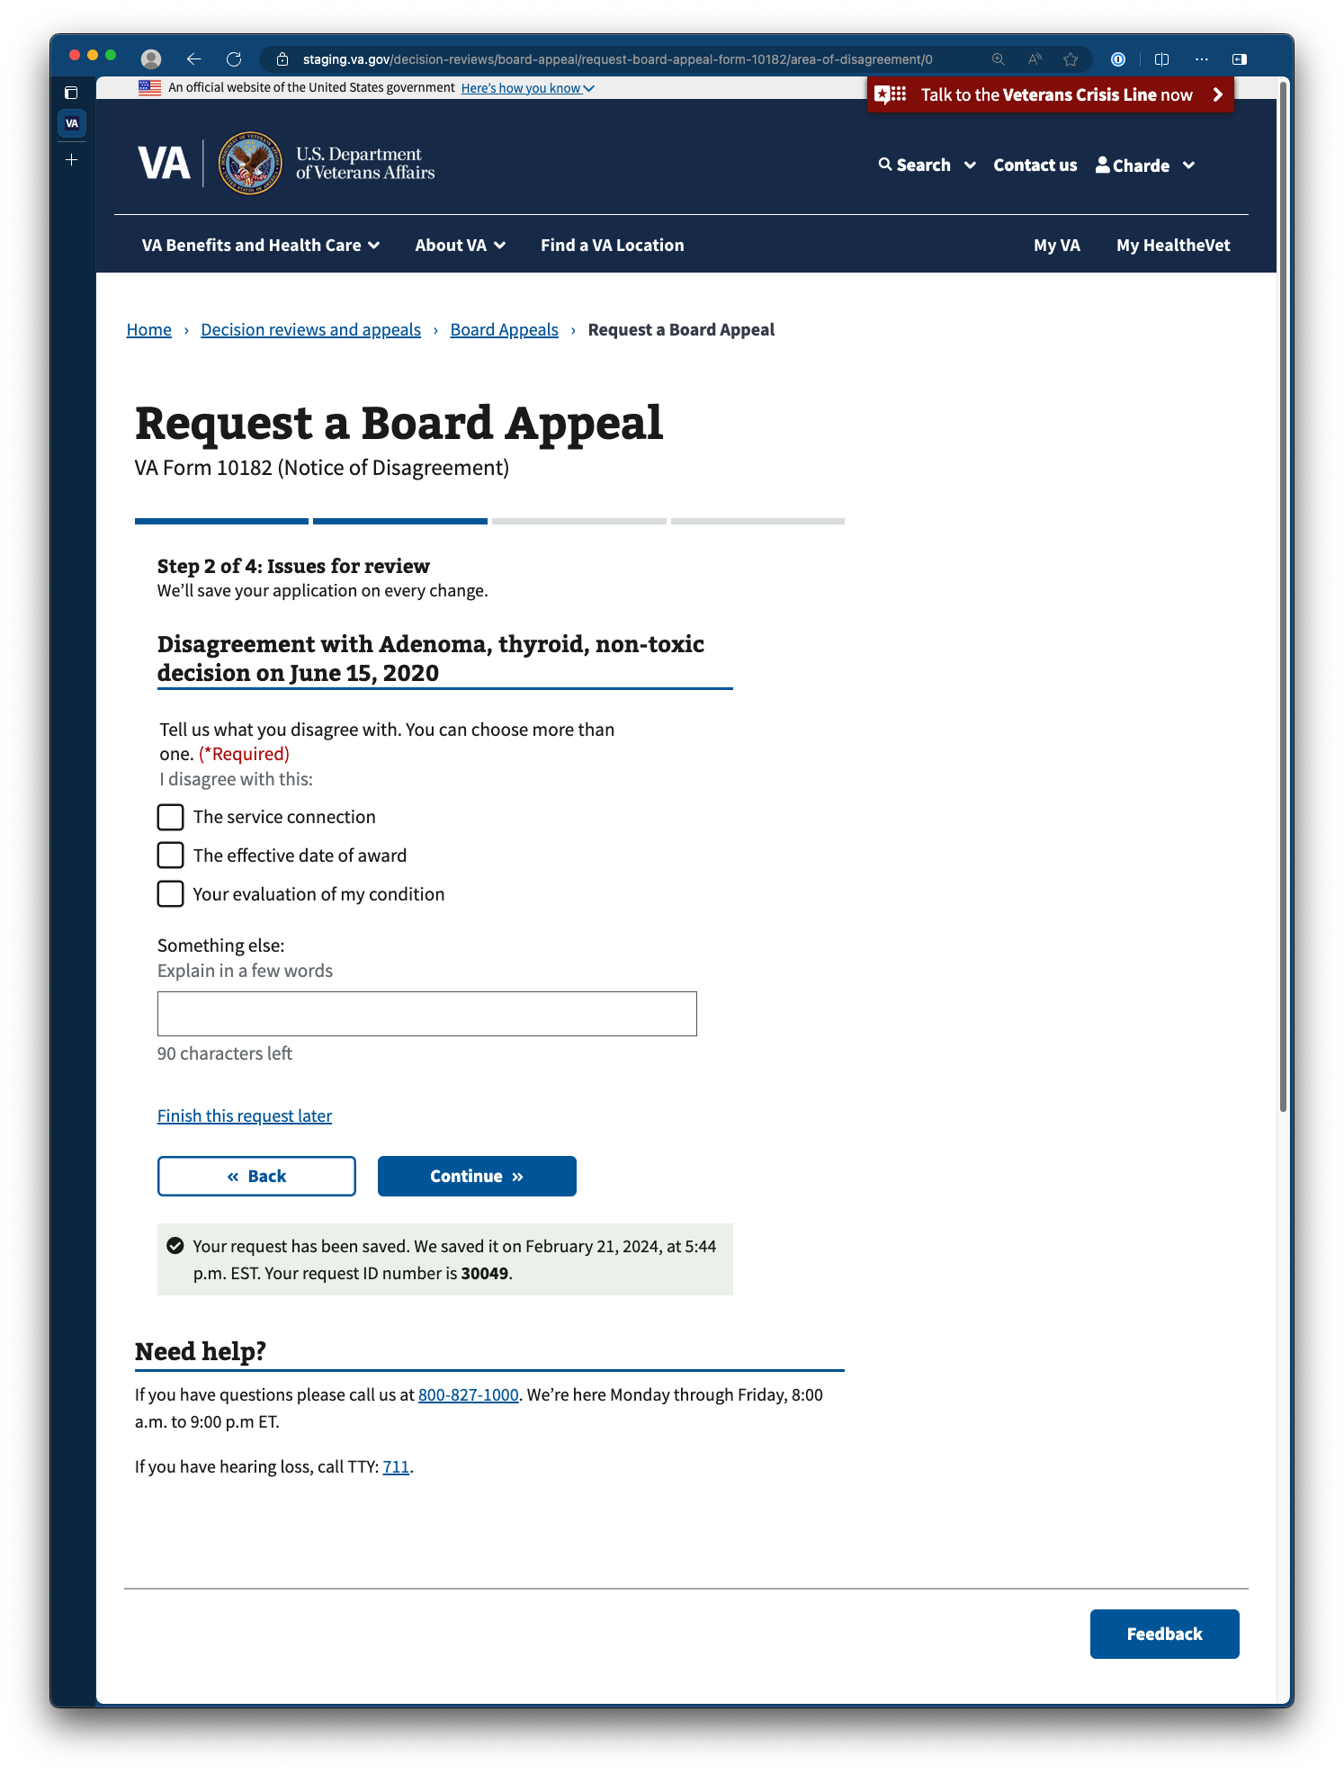

### Reviewing issues for appeal

Before continuing with the appeal, Veterans will have the opportunity to review the issues and associated reasons for disagreement they’ve chosen to include as a part of their appeal. Should they decide to revise, amend, or remove one of their listed issues, they can do so by navigating back or clicking the action labeled go back and add it.

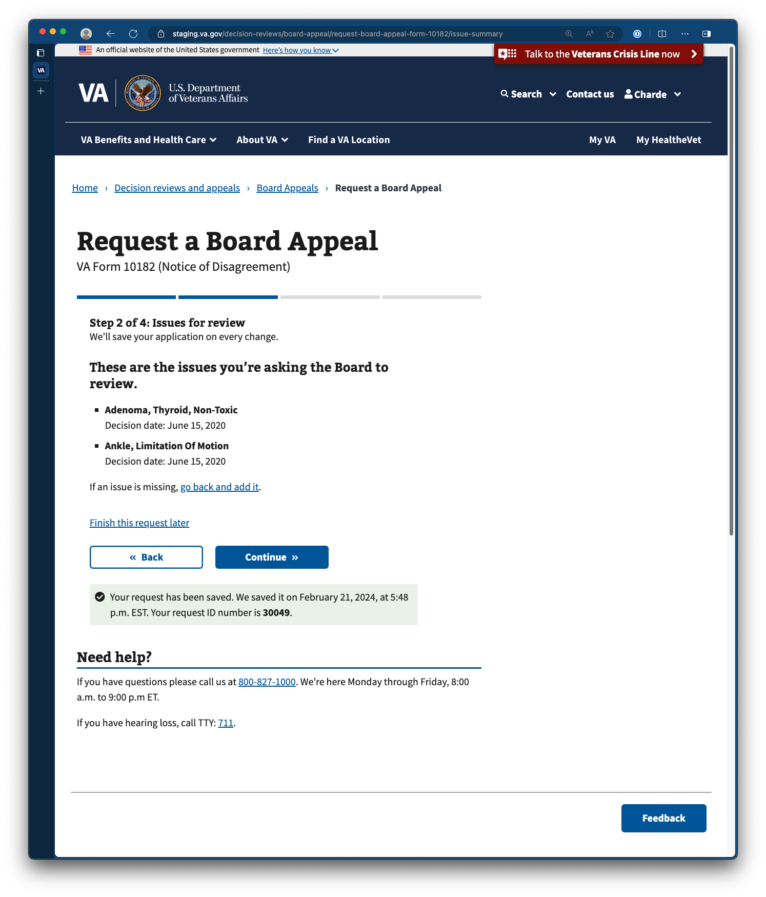

## Step 3: Select a Board Review Option

As the Veteran continues with their appeal request, they’ll be prompted to select their board review option. Veterans will need additional steps to select options to submit more evidence or request a hearing.

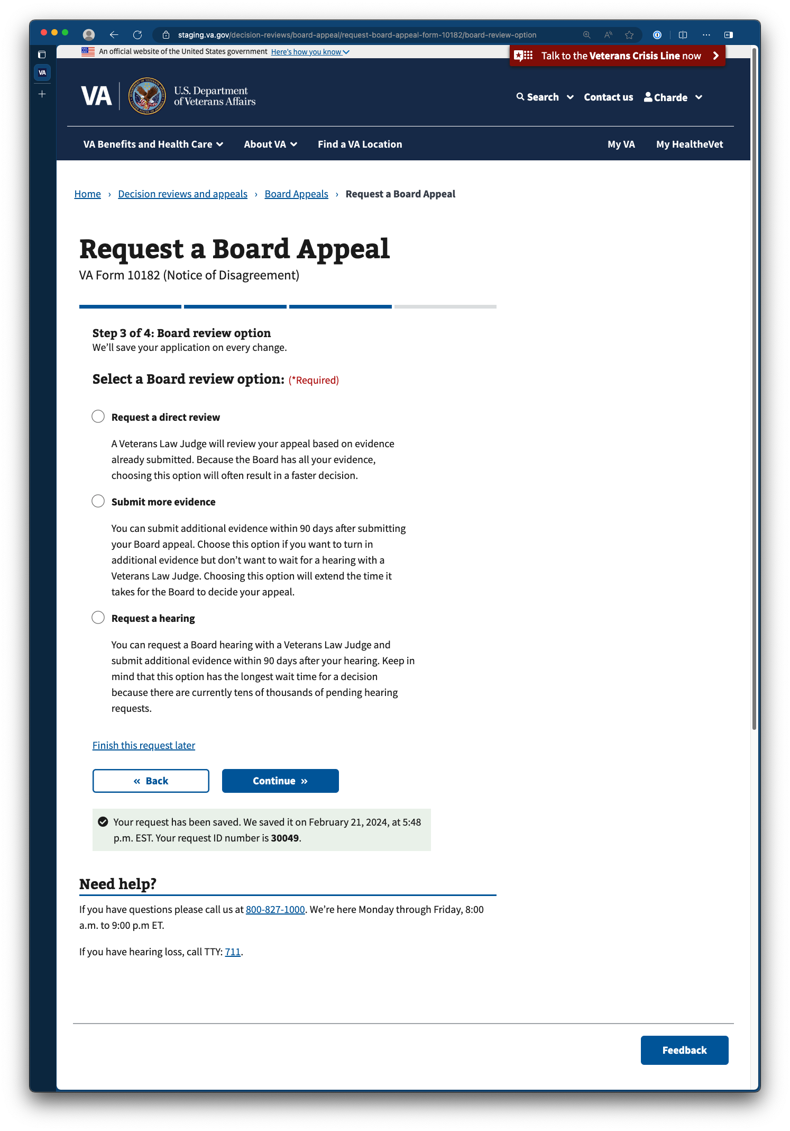

#### Submitting additional evidence (for Veterans opting to submit more evidence)

Veterans opting to submit more evidence can include it alongside their appeal request or submit it later.

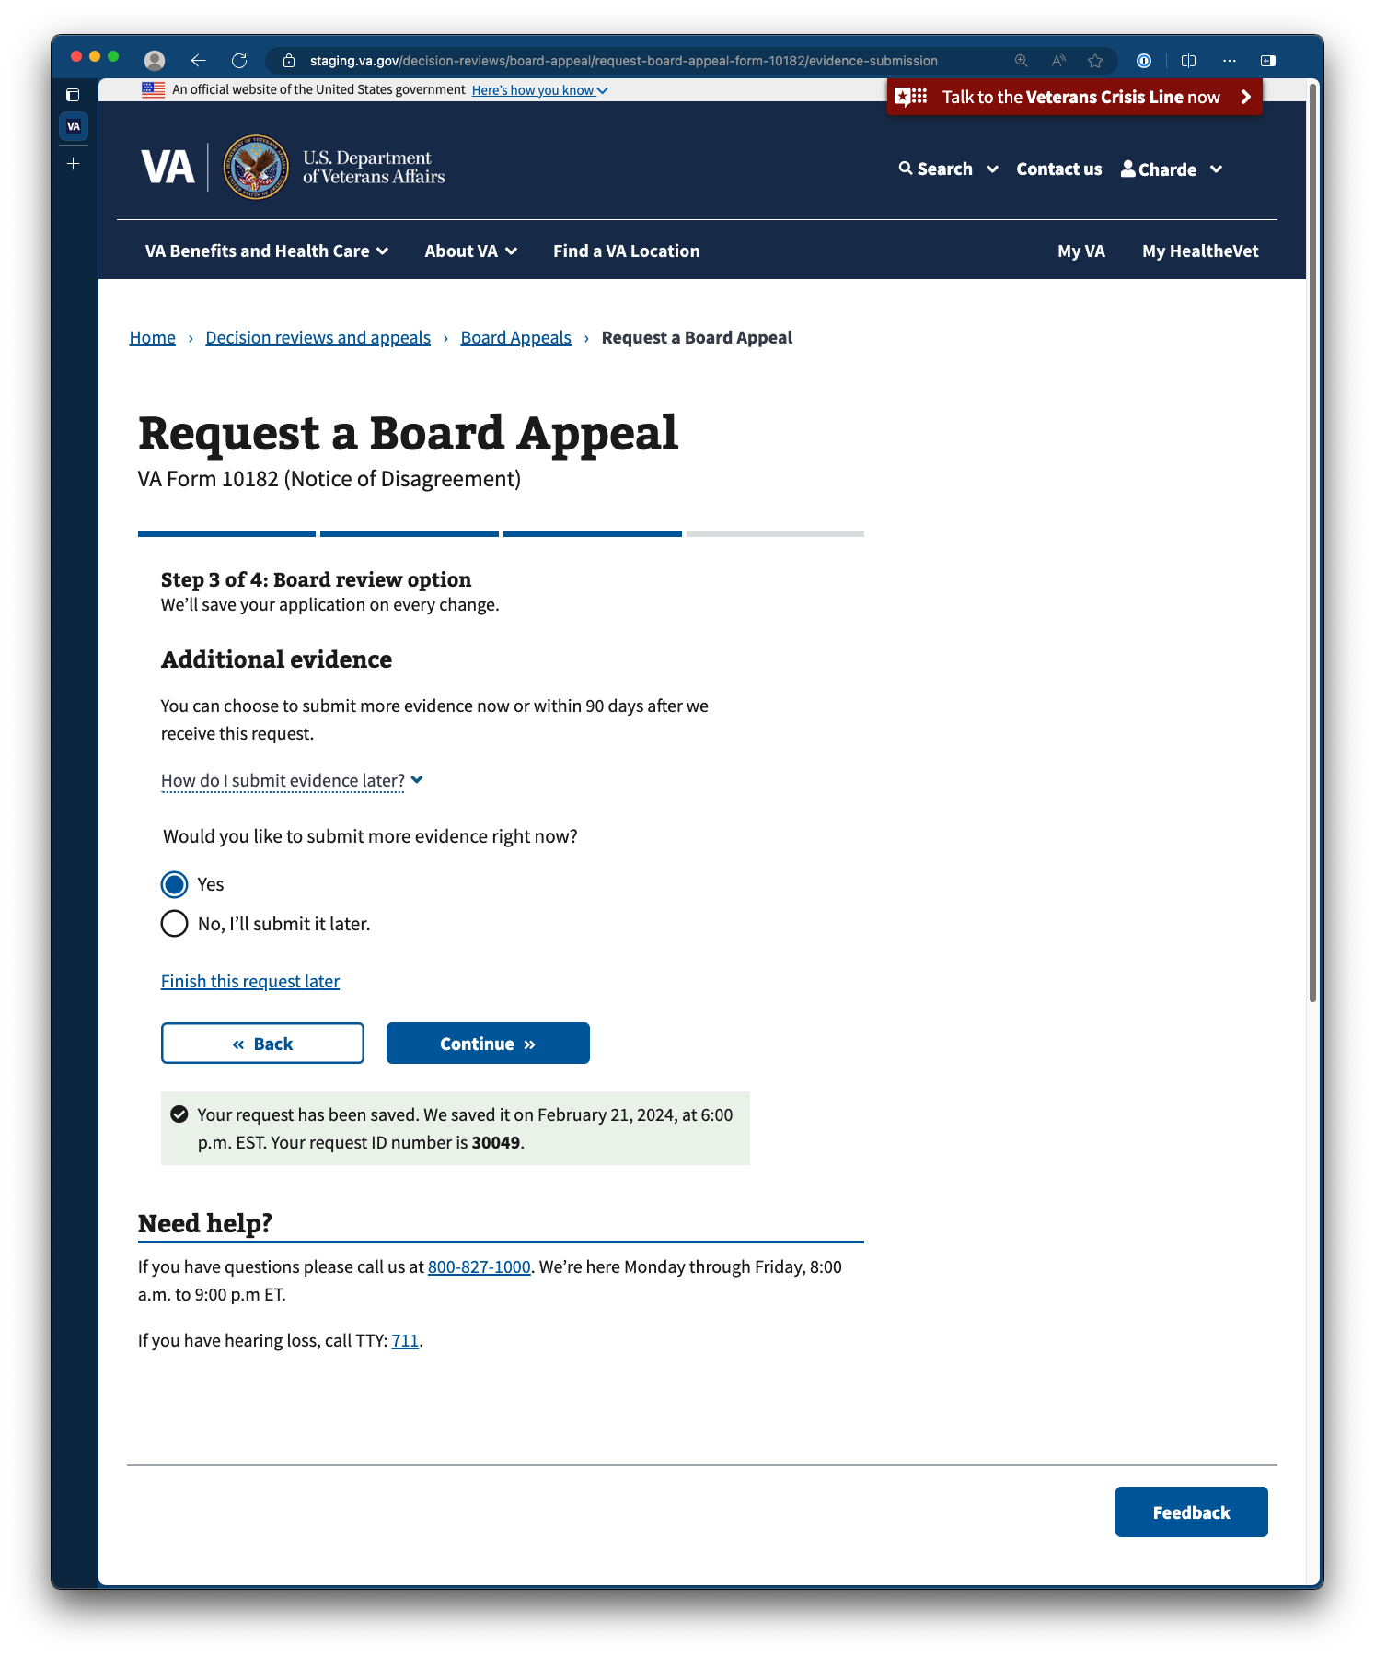

By selecting yes, Veterans will be provided the ability to upload multiple documents to their appeal request. As the instructions indicate, Veterans are limited to uploading files in PDF format, with a size of up to 100 MB.

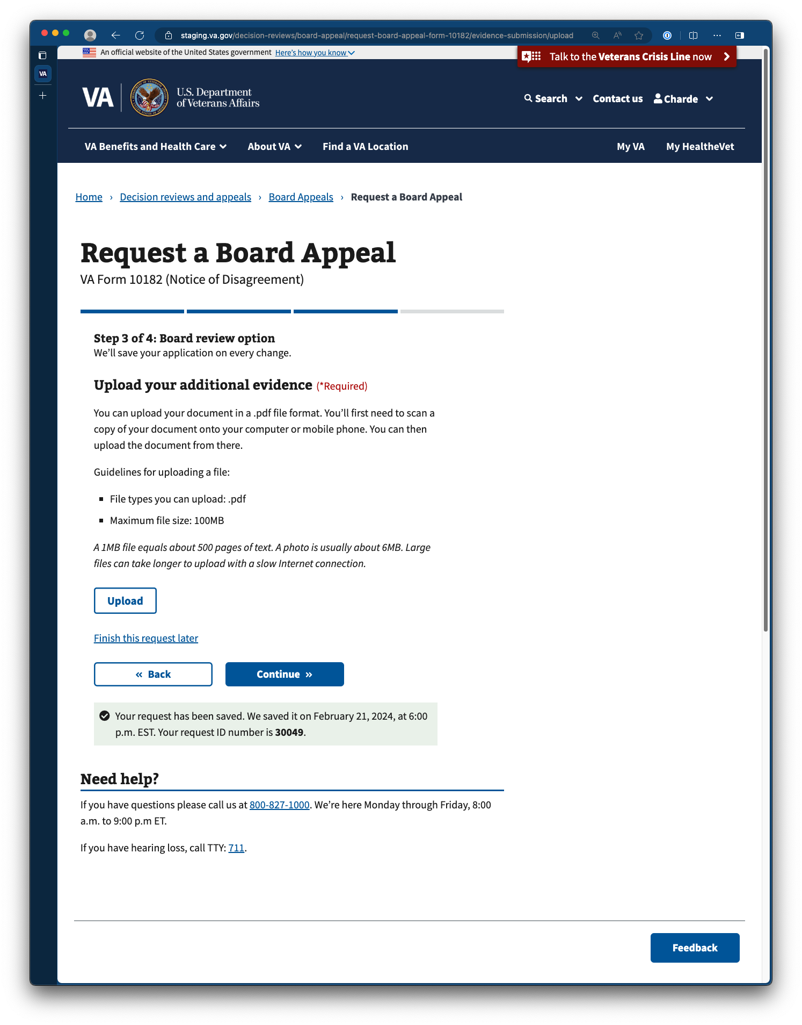

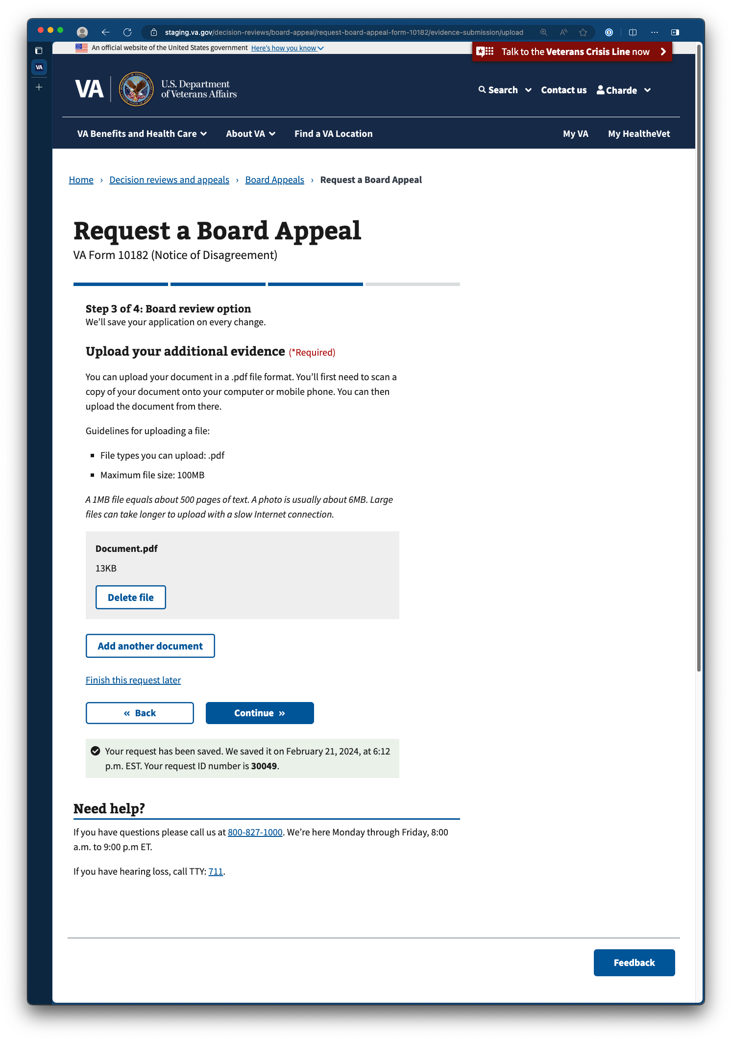

#### Selecting a hearing option (for Veterans opting to request a hearing)

Veterans opting for an appeal can select the type of hearing they wish to attend.

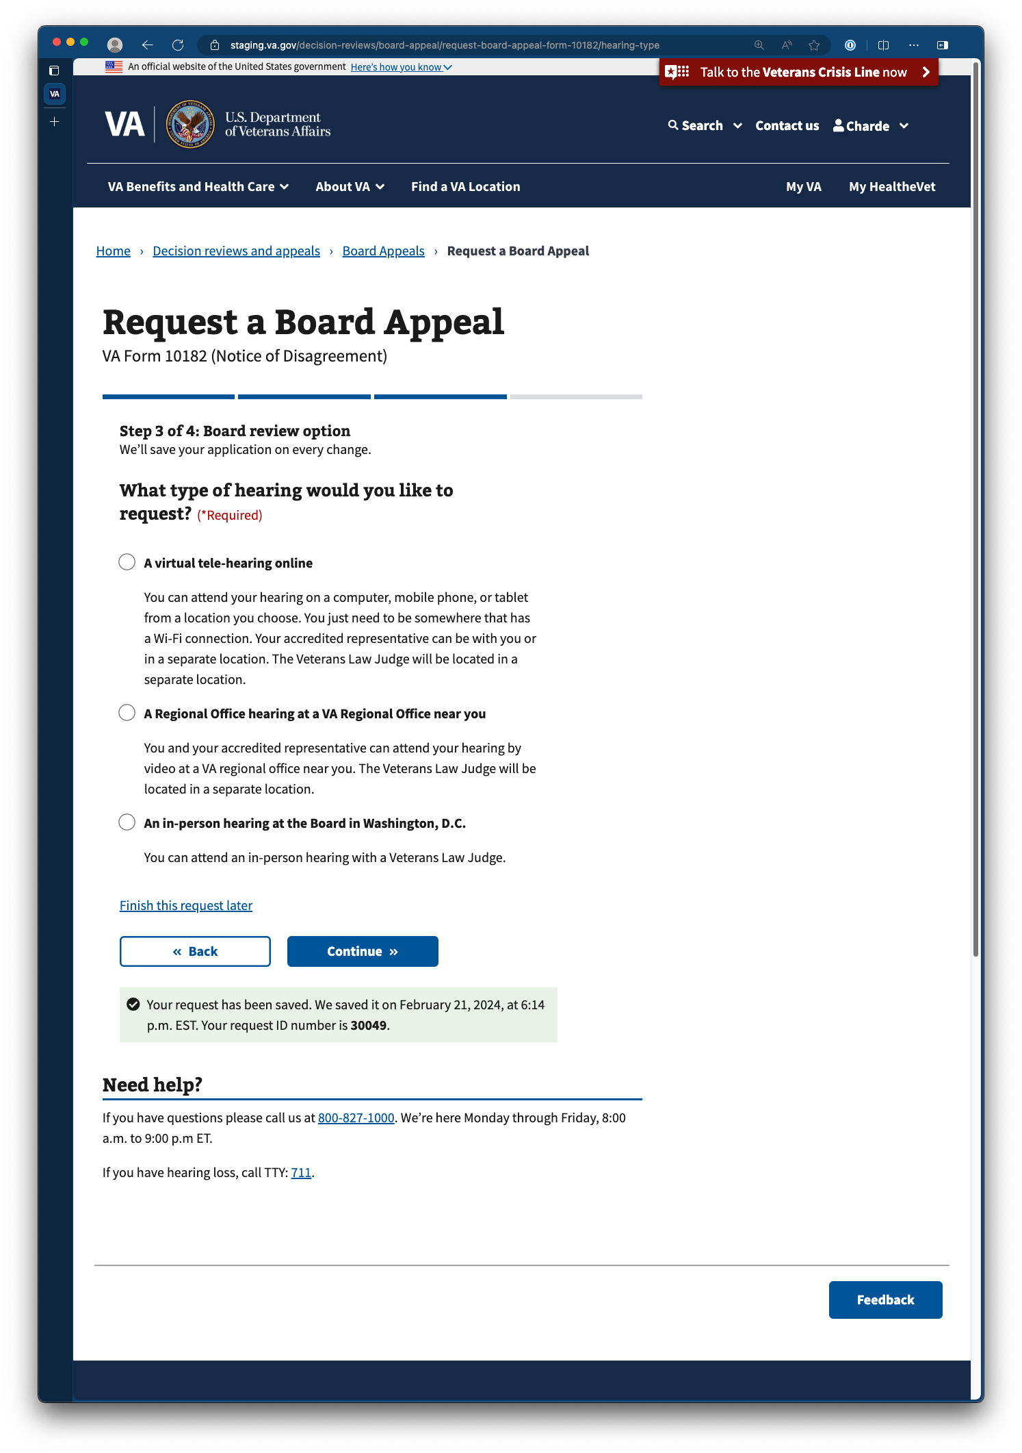

## Step 4: Review and Submit Appeal Request

### Viewing responses

Before submission, Veterans are provided the opportunity to review their appeal request. Veterans can review the details of each section by clicking on the expend controls on the right side of each section title listed.

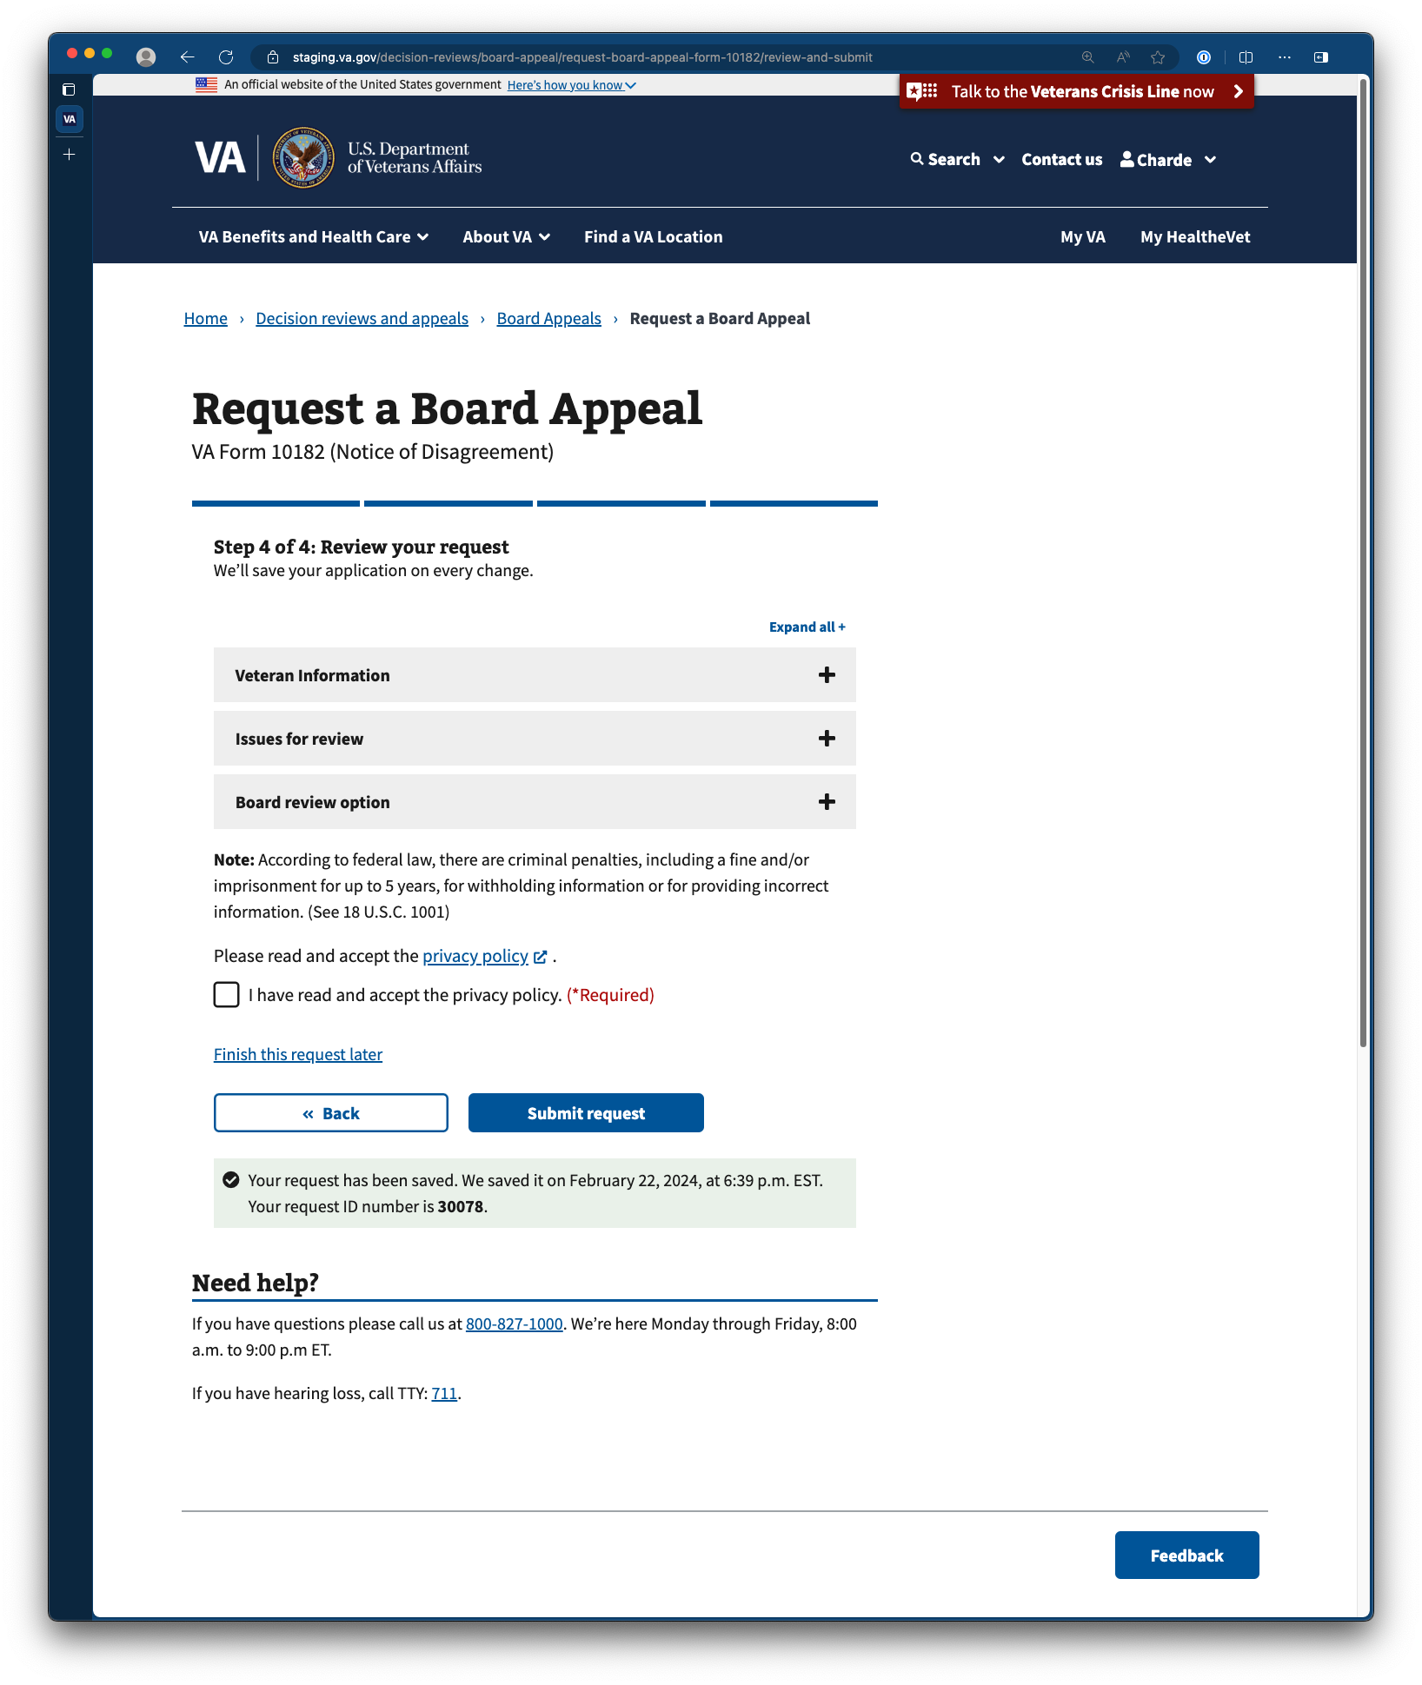

### Editing responses

Within each form section, clicking on the edit button on the right side of each item will allow Veterans to edit each response in line.

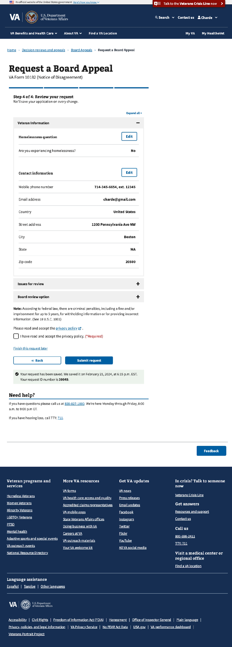

As they edit their response, they can commit changes by clicking “update page.” Otherwise, they can click “update page” without changing their response to retain what they initially provided.

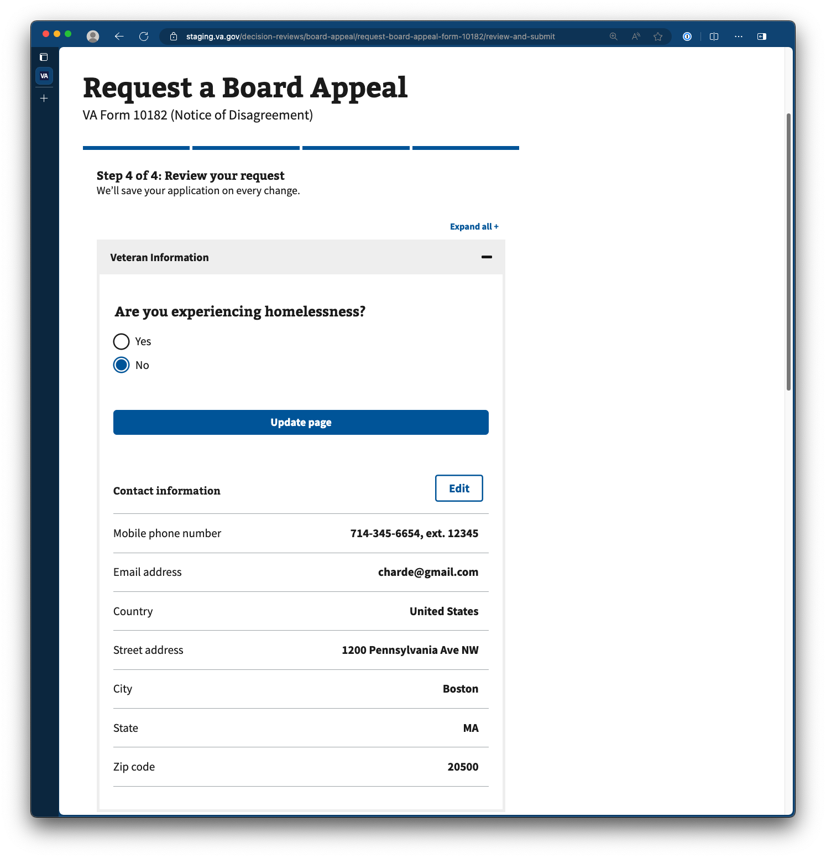

Changed responses requiring additional information

Sometimes, changes to specific responses require Veterans to provide additional information elsewhere in the request form. In these instances, they will see an alert indicating that Some information has changed. Please review.

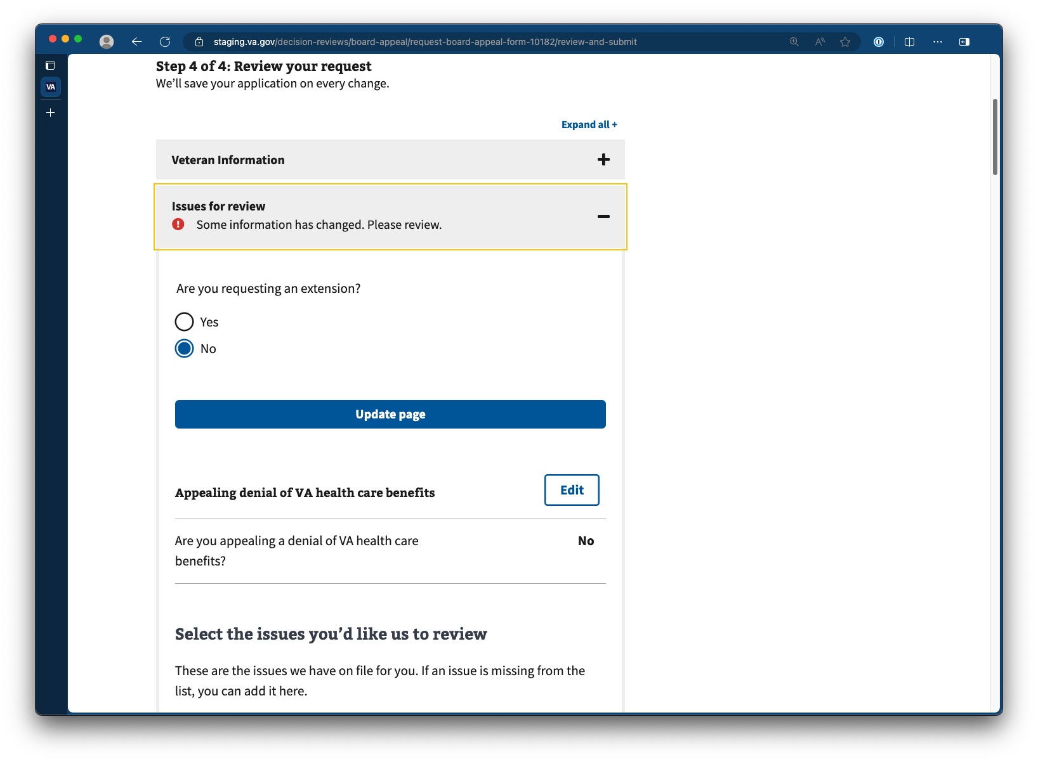

Responses needing their attention will be indicated in red, as depicted below.

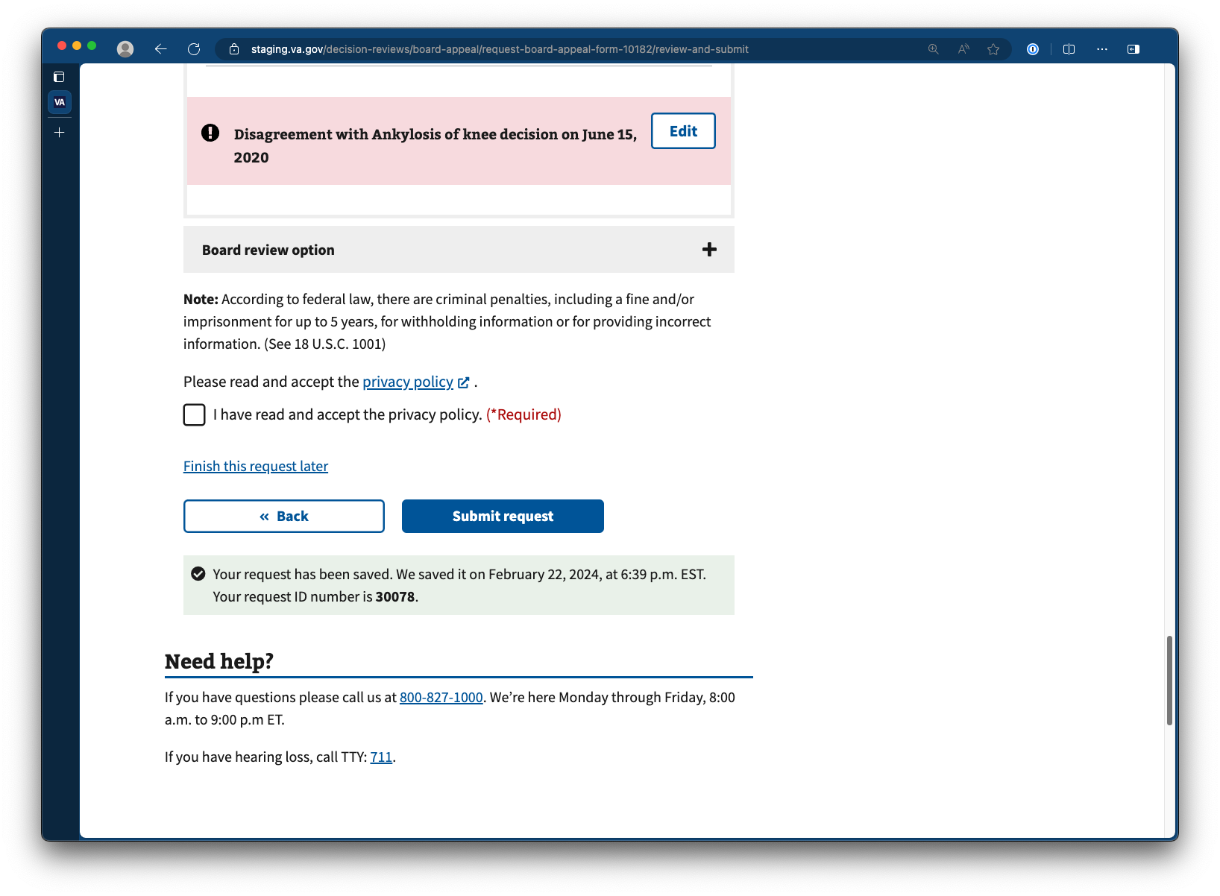

### Submitting the appeal request

To submit the appeal request, Veterans must first read and accept the privacy policy.  
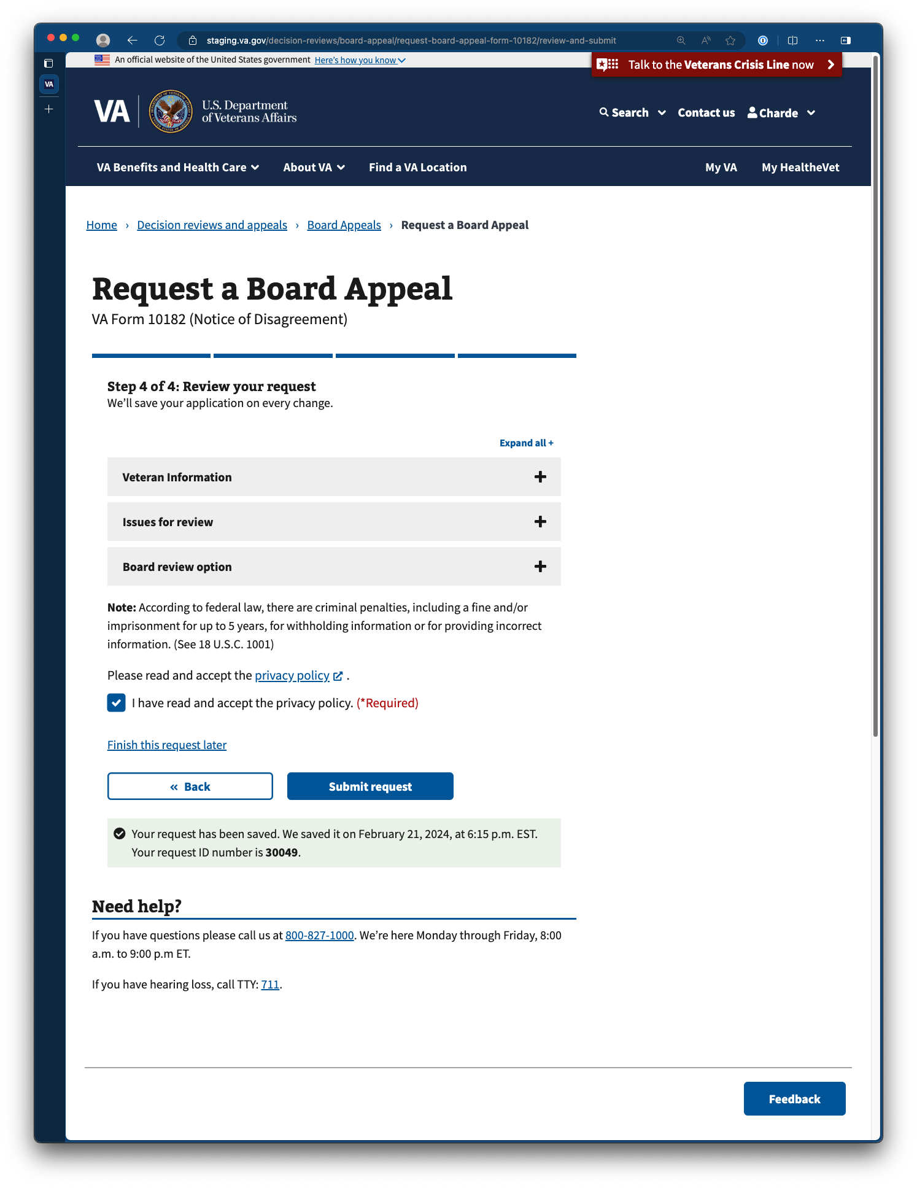

#### Appeal request submission confirmation

Once the appeal request has been submitted, Veterans will receive a confirmation for their appeal request.

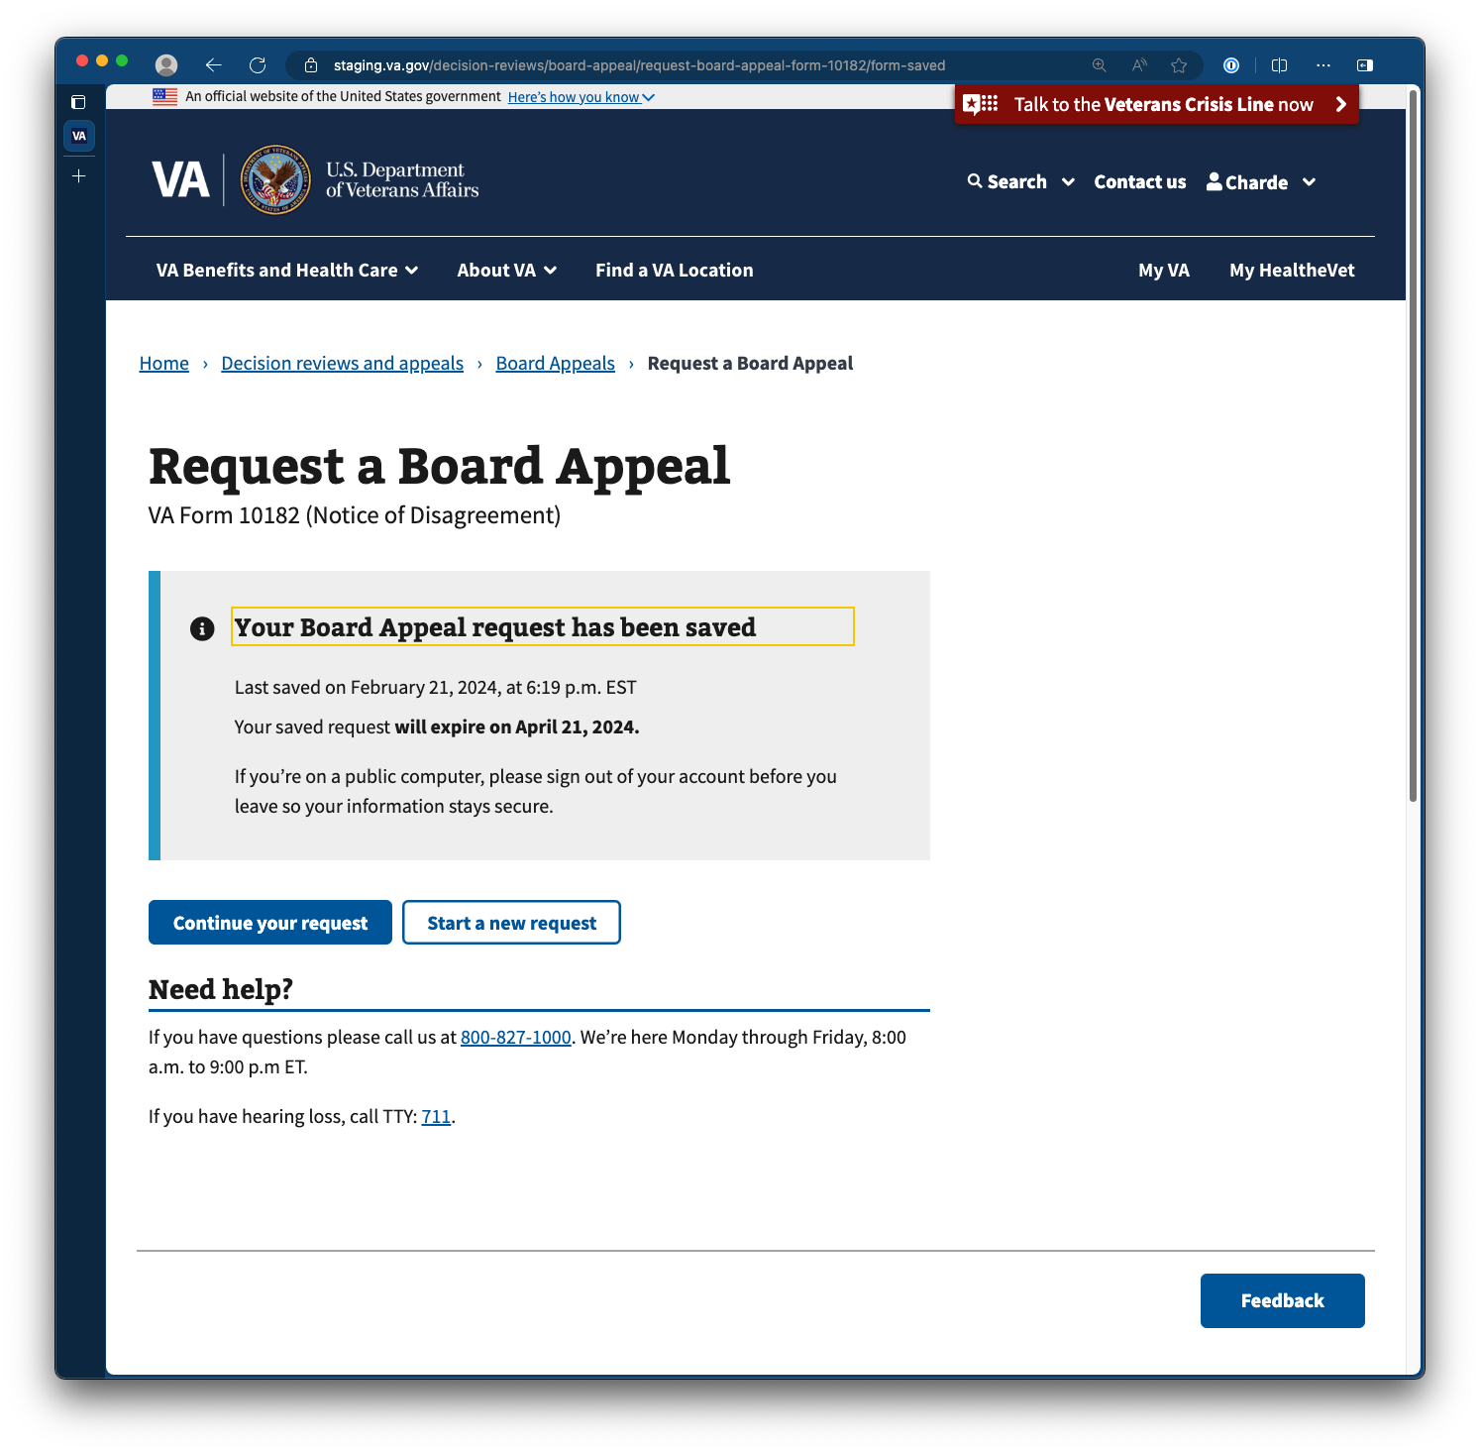

## Saving progress and returning to the submission request

### Saving progress

Progress is automatically saved each time Veterans respond to each form prompt. A banner at the bottom of each form page will indicate the last time the appeal request has been saved.



At any point in time, Veterans are also able to exit the form and retain their work in progress by clicking on the Finish request later link or simply closing out the appeal request window.



### Resuming progress

To resume progress with a partially complete appeal request, Veterans can either navigate directly back to the form URL or locate a link to a draft of their appeal request on their MyVA page. This link can be found in the section titled Benefit application drafts. VA.gov retains 1 board appeal request form draft at a time. In-progress appeal requests are saved for 2 months before expiring.

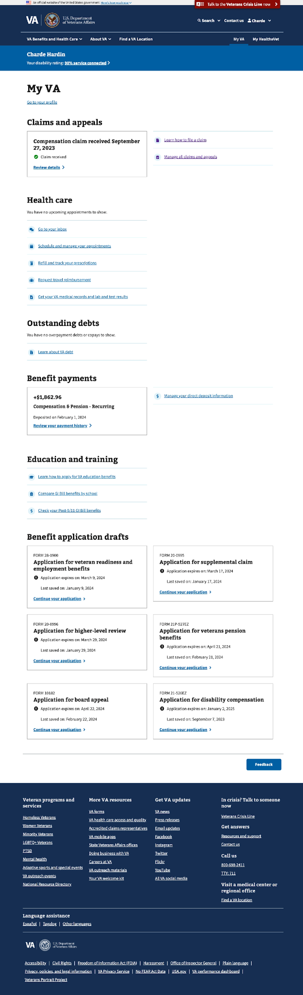

### Starting over

Upon returning to a draft of an in-progress board appeal request, Veterans can start over with their appeal request. To do so, Veterans must select the action to Start a new request.

This action will clear out all the responses the Veteran had previously entered and allow them to start over from the beginning.

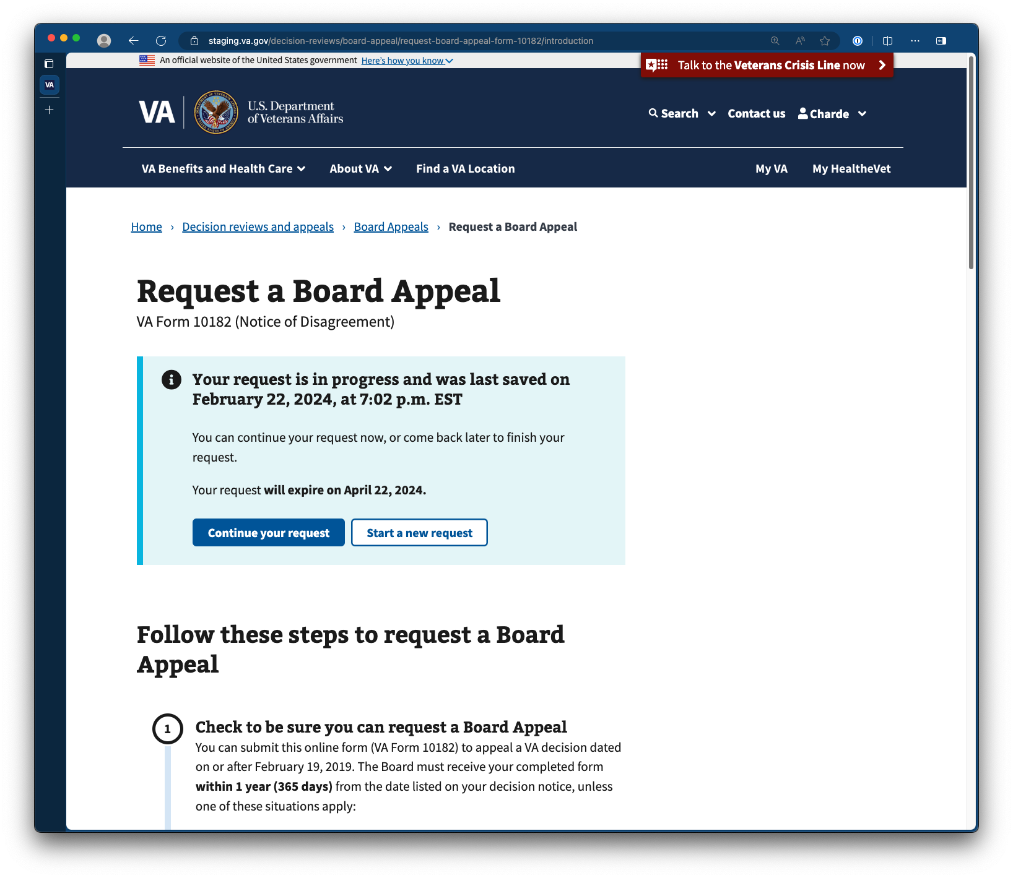

## **Email Error Notification**

Suppose the Board Appeal form fails at any point post-submission. In that case, we will send the Veteran an “action needed” email notifying them that their form submission has failed and that they should resubmit it by mail, in person, or by fax to avoid further issues.

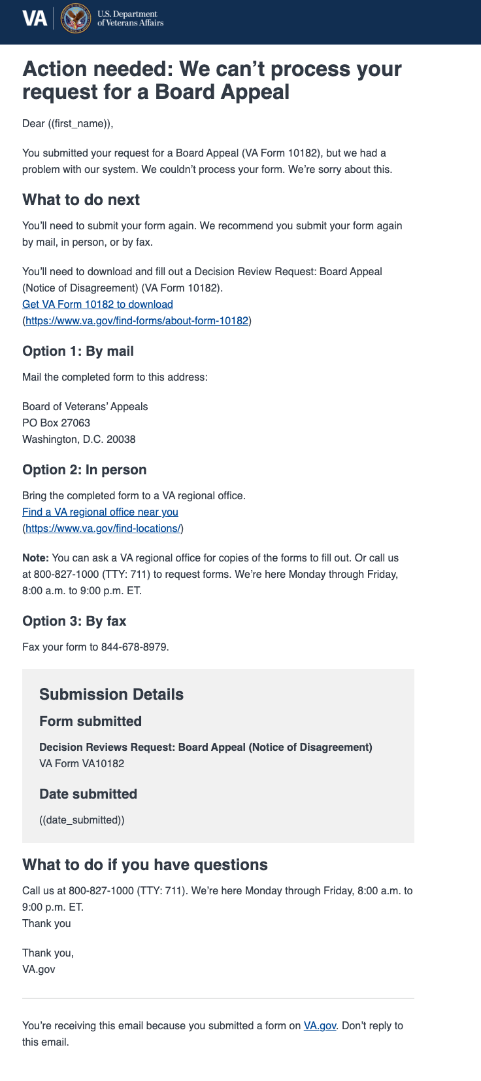

Suppose the Board Appeal supporting document fails at any point post-submission. In that case, we will send the Veteran an “action needed” email notifying them that their supporting document submission has failed and that they should resubmit the form by mail, in person, or by fax to avoid further issues.

